  your details
  Please use CAPITALS to make it easier for us to read, so we don’t make any mistakes.
  TIMESHEET
  TIMESHEET:
  REF nUMBER
  COPIES: White Copy – your copy (Send PDF to office)
  Blue Copy – Unit or Ward/ Home (placement)
First Name: ______________________________ Surname: ______________________ Unit/Ward/Home ________________________
Where have you been working?
a Copy of this TIMESHEET needs to be with PayRoLL by 10am Monday (we only want it by then, so that we can pay you on time.)  - You can submit through the website (3) Or pop into the office & say Hello  - you can Email this over to the oFFICE – timesheets@care247healthcare.co.uk | If you are going to email this across, we recommend you use your smart phone (download the app TIny SCannER) we recommend that you CC yourself on the email. only when you see the email sent to yourself, will you guarantee that you have done everything to ensure it’s been received.

your working week Monday to Sunday. Fill in the daTE below. Please state the TIME of work & also state (tick/cross) aM or PM. Tick/cross if you slept over on shift CLIEnT SIGnaTURE BELoW onLy
Ha01
Care 24/7 Healthcare Limited
address: 1-3, MaP House, St Leonards Road, Eastbourne, Bn21 3UT
T:
01323 370232 |
E:
timesheets@care247healthcare.co.uk

W:
www.care247healthcare.co.uk | Registration number: 09909827
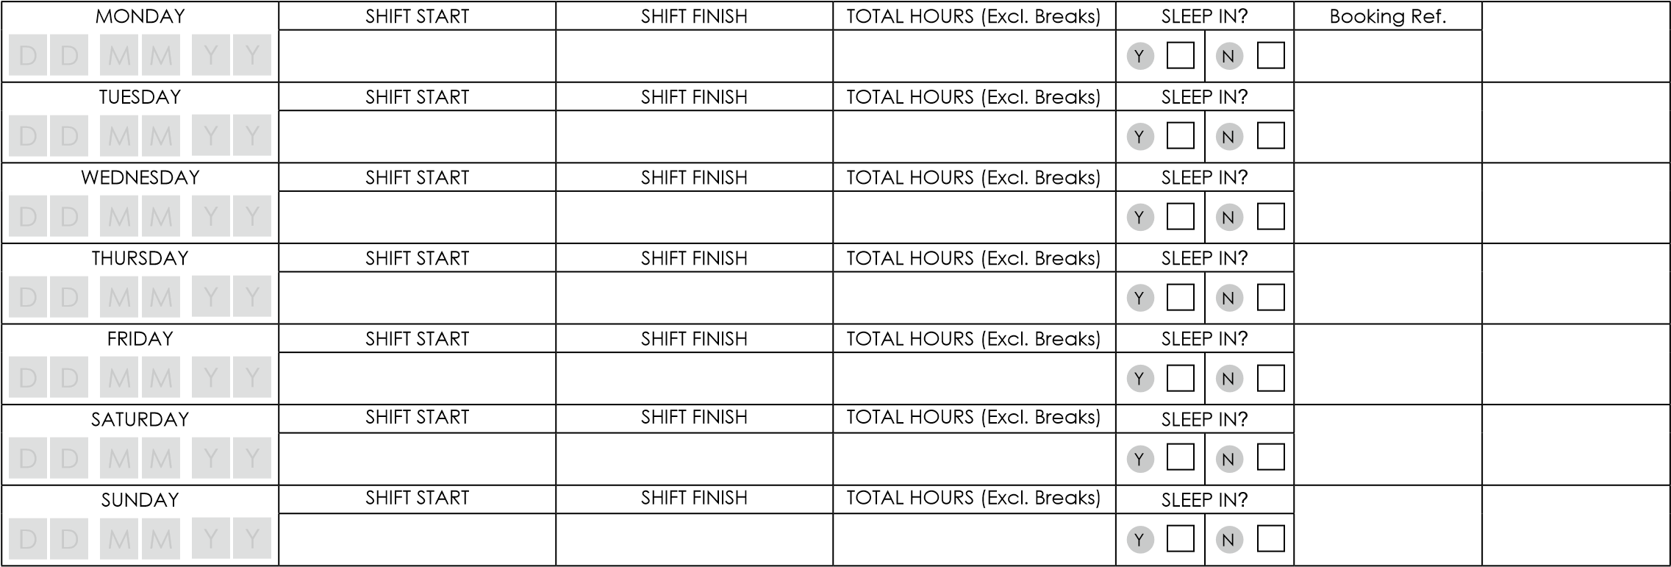
SIGnEd By yoU: The above hours are correct & I performed my duties to the best of my ability  daTE & SIGnaTURE | d d M M y y  _________________________________ | SIGNED BY END CLIENT: I can confirm that the (above) has completed the above hours. I am authorised within my position to sign this timesheet.  Full Name:___________________________________  Position: _____________________________________ daTE & SIGnaTURE | d d M M y y  ____________________________________
your working week is now complete – just one more task to perform. To ensure you get paid correctly & on time (see Below)

