Job Application
BS2.1
Care 24/7 Healthcare Limited
Address: 1-3, MAP House, St Leonards Road, Eastbourne, BN21 3UT
T:
01323 370232 |
E:
info@care247healthcare.co.uk
W:
www.care247healthcare.co.uk | Registration Number: 09909827
POSITION APPLIED FOR: | Job Reference:
Please complete this Application Form in block capitals in black or blue ink. Should you require more space please continue on a separate sheet clearly marking the section to which it relates.
A: PERSONAL DETAILS
Title (Mr /Mrs /Miss /Ms /other): ____________
Surname: _________________________________________ Forename(s): _____________________________________
Address: ______________________________________________________________________________________________
_______________________________________________________________ Postcode: ____________________________
Telephone: Private: _____________________ Business: ______________________ Mobile: __________________
E-mail address: _______________________________________________ This address is: Personal Work
Do you need a permit to work in the UK? YES: NO:
B: DRIVING RECORD
Do you have regular use of a car? YES: NO: Make / model / year:__________________________ Current Driving Licence: PROVISIONAL: FULL: PSV: NONE:
Driving Licence valid from: _____________________________________ to: ____________________________________
Details of current endorsements : ______________________________________________________________________
Do you have any driving-related prosecutions / fixed penalties / endorsements or similar currently pending? YES: NO:
If “YES” please provide brief details: ____________________________________________________________________ Have you ever been disqualified from driving? YES: NO:
If “YES” please provide brief details: ____________________________________________________________________ Have you ever had insurance refused? YES: NO:
If “YES” please provide brief details: ____________________________________________________________________

C: EDUCATION & PROFESSIONAL TRAINING (from year 11)
Education Centre (school, college etc) | DATES |  | Qualifications gained
Education Centre (school, college etc) | From | To | Qualifications gained
1. Secondary Education (secondary school)
2. Higher Education (university / college / polytechnic)
3. Further Education (Professional Training)
4. Membership of Professional Organisations
D: LANGUAGES
Languages (other than English) : ______________________ SPOKEN FLUENT WRITTEN READ
__________________ SPOKEN FLUENT WRITTEN READ
__________________ SPOKEN FLUENT WRITTEN READ
E: PERSONAL DBS CERTIFICATES
If the position you are applying for (whether paid or voluntary) is listed in Schedule 1, Part II of the Rehabilitation of Offenders Act (Exceptions) Order 1975, we are entitled to ask Exempted Questions as defined by Section 113(5) of the Police Act 1997 about you. We are required to check a DBS Certificate in relation to any person who is a Care Manager or Care Worker. If your application is successful and before your appointment is confirmed, you will be required to submit a personal current and valid DBS Certificate for our inspection.
Having a criminal record will not necessarily bar you from working with us. This will depend upon the nature of the position and the circumstances and background of your offences. We observe the “Code of Practice for Registered Persons and Other Recipients of Disclosure Information” published through the Disclosure & Barring Service on behalf of the Home Office, and we will provide you with a copy of it upon request.
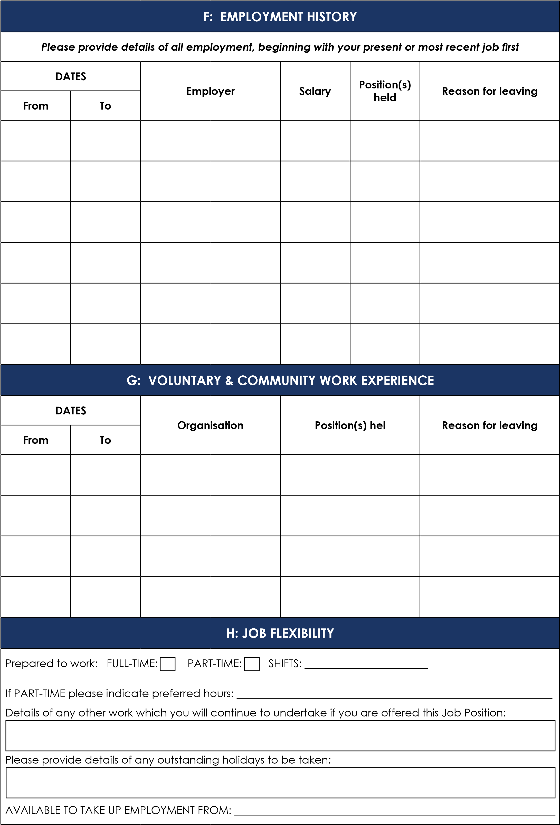

I: REFERENCES
Please provide details of 2 referees who we may approach with regards to this Job Application. These referees must not be members of your family, and one must be your present or most recent employer:
- Name: _____________________________________________________________________________________________
Address: ___________________________________________________________________________________________
____________________________________________________________________________________________________
Telephone Number: ________________________________________________________________________________
Occupation: _______________________________________________________________________________________
- Name: _____________________________________________________________________________________________
Address: ___________________________________________________________________________________________
____________________________________________________________________________________________________
Telephone Number: ________________________________________________________________________________
Occupation: _______________________________________________________________________________________
May we contact your referees prior to making a job offer? YES: NO:
J: DECLARATION BY JOB APPLICANT
ANY PERSON, UPON SUBSEQUENT EMPLOYMENT, THAT IS FOUND TO HAVE KNOWINGLY SUPPLIED FALSE OR
MISLEADING INFORMATION, OR HAS DELIBERATELY WITHHELD RELEVANT INFORMATION, MAY BE SUBJECT TO DISCIPLINARY PROCEEDINGS WHICH MAY RESULT IN DISMISSAL
I have read and understood the information supplied to me in relation to this Job Position, and the information requested in this Job Application Form. I confirm that all information supplied by me is true and correct to the best of my beliefs.
I give the prospective employer the right to follow up all references and to make any other job-related enquiries as may be deemed necessary.
Signature: _____________________________ Date: ______________________
(_______________________________________________) IS AN EQUAL OPPORTUNITIES EMPLOYER
The sole criterion for selection of applicants will be suitability for the Job Position, regardless of gender, background, culture, ethnic denomination, religious affiliation, marital status or disability.
Data Protection Act 1998: Your signature on this document gives us the right, under the Data Protection Act 1998 to process the information you have given, including data of a sensitive nature, relating to your application for employment. Any processing of the data by us will be in accordance with our Policy and the processing principles set out in the Act. Application forms of unsuccessful candidates will be destroyed after 6 months in accordance with our Record-keeping Policy.

