Employee Exit Interview
BS2.19
Care 24/7 Healthcare Limited
Address: 1-3, MAP House, St Leonards Road, Eastbourne, BN21 3UT
T:
01323 370232 |
E:
info@care247healthcare.co.uk
W:
www.care247healthcare.co.uk | Registration Number: 09909827
Name: | Department:
Date employment started: | Date employment terminated:
Supervisor: | Salary / Pay:
ELEMENT | COMMENTS
What did you like most about your job, and why?
What did you like least about your job, and why?
Did you have a Job Description, and if so do you feel that it fairly described the job content / duties you were asked to do?
Your opinions of the workload of the job?
Your opinion of the training you received (induction training / “on-the-job” training / any specialist training you had)?
What do you feel about the prospects for promotion / career advancement from this job?
Do you have any suggestions for improving the job content?
Have you offered these suggestions in the past? If so, to whom and when, and what was the outcome?
Overall, why have you decided to leave our employment?
Will you be taking up another job when you leave? If so, what is it and why do you feel that it will be better for you?
Would you recommend our Organisation to others for employment, and if not why not?
Overall, what do you think of the Organisation’s reputation as an employer?
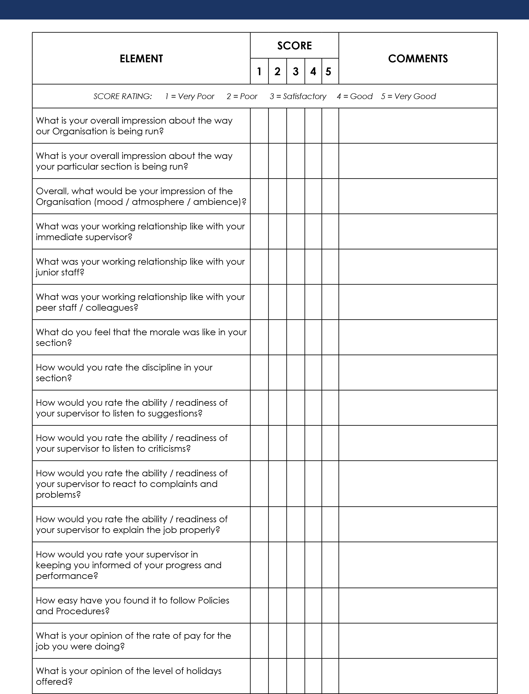

ELEMENT | SCORE |  |  |  |  | COMMENTS
 | 1 | 2 | 3 | 4 | 5
SCORE RATING: 1 = Very Poor 2 = Poor 3 = Satisfactory 4 = Good 5 = Very Good
How do you rate the support you have received in furthering your job prospects?
How do you rate the support you have received in furthering your professional qualifications?
How do you rate the general working conditions within the Organisation?
Reason for leaving (opinion of the interviewer):

_____________________________ ____________________
Signature Date

