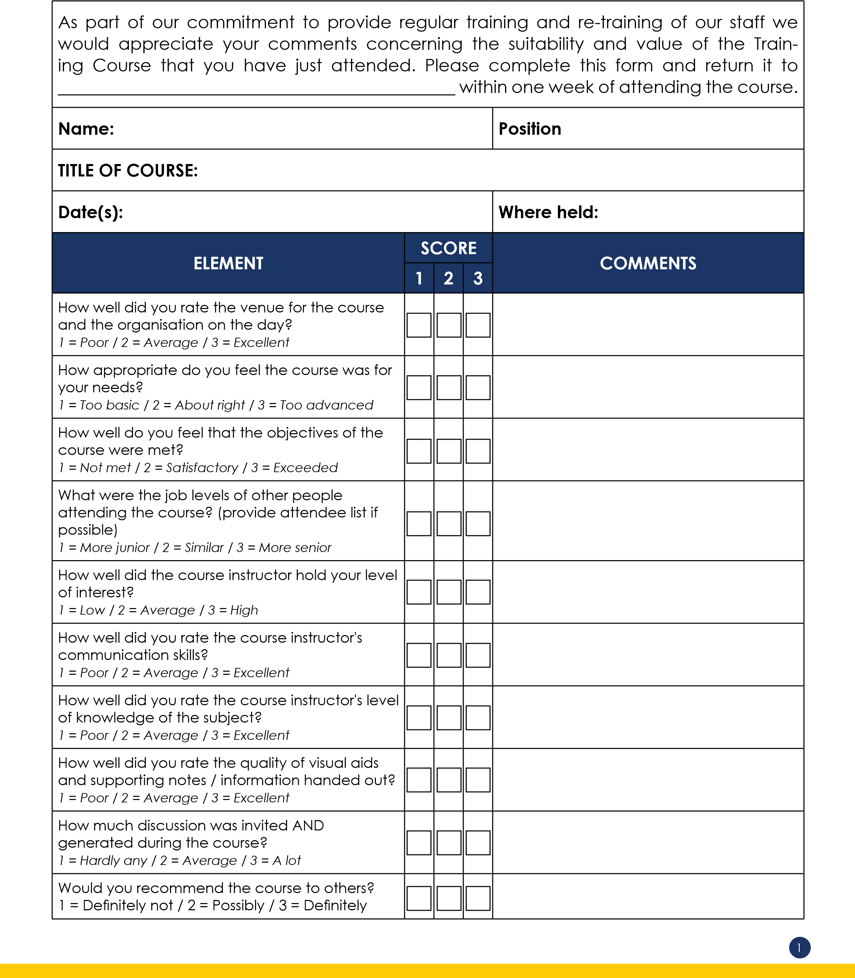
Appraisal of External Training Course
BT4
Care 24/7 Healthcare Limited
Address: 1-3, MAP House, St Leonards Road, Eastbourne, BN21 3UT
T:
01323 370232 |
E:
info@care247healthcare.co.uk

W:
www.care247healthcare.co.uk | Registration Number: 09909827
2
What was your overall impression of the course and the way it was run? Indicate your overall assessment of the course instructor, visual aids and hand-outs used, and general strengths and weaknesses.
What aspects of your job responsibilities do you feel will improve as a result of you attending this course?
What specific improvements will you make to your job activities?
What personal benefits do you feel you have received as a result of attending this course?
Do you expect any significant improvements in the way your area of responsibility within the Organisation is run or managed as a result of you attending this course?
What additional training do you feel you would need to enable you to achieve your job AND personal objectives?
GENERAL COMMENTS:
Employee: ___________________________ Date: ____________________

