Staff Performance Appraisal
BT8
Care 24/7 Healthcare Limited
Address: 1-3, MAP House, St Leonards Road, Eastbourne, BN21 3UT
T:
01323 370232 |
E:
info@care247healthcare.co.uk
W:
www.care247healthcare.co.uk | Registration Number: 09909827
Name: | Appraisal Interview Date:
Job Position: | Job Status / Reference:
A: PRE-APPRAISAL QUESTIONNAIRE (to be completed by employee)
ACHIEVEMENTS:
What do you consider to have been your main achievements in your job since your last appraisal?
PROBLEMS:
What problems or difficulties have you experienced in your work since your last appraisal, and how have these affected your achievements or objectives?
ACTION:
What action do you feel needs to be taken for these problems to be corrected and / or prevented from recurring?
OBJECTIVES:
What are your job / career objectives for the next 12 months?
TRAINING:
What additional training do you feel you would need to enable you to achieve these objectives?
General comments:
Employee: _____________________________ ______________________
Signature Date
Supervisor: _____________________________ ______________________
Signature Date
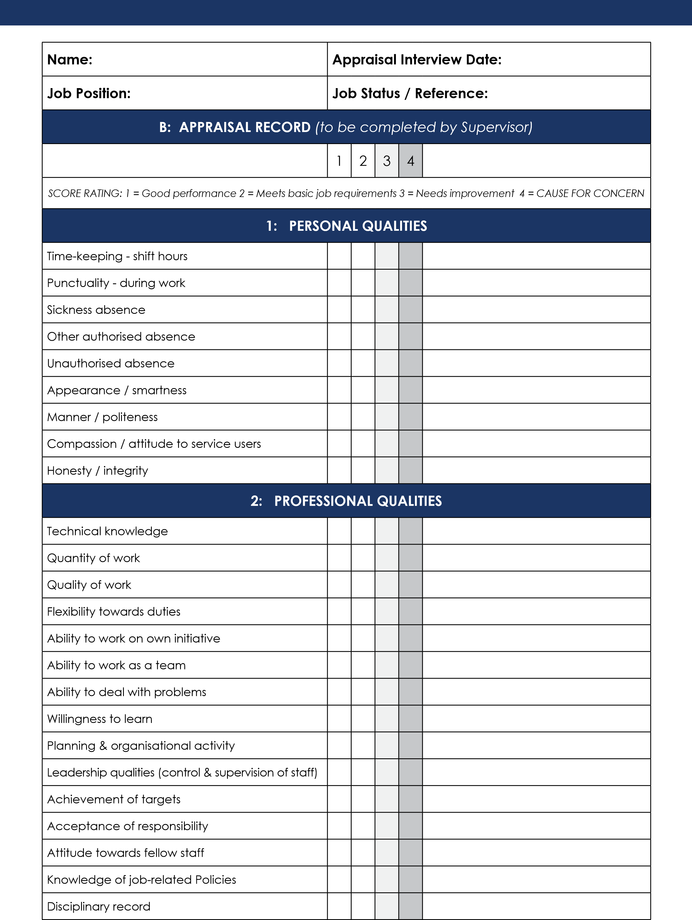

Name: | Appraisal Interview Date:
Job Position: | Job Status / Reference:
B: APPRAISAL RECORD (to be completed by Supervisor)
STRENGTHS
WEAKNESSES:
TARGETS ACHIEVED:
PROBLEMS ENCOUNTERED:
DISCIPLINARY RECORD: | Verbal Warnings:_____________________________________  Written Warnings:_____________________________________
TRAINING REQUIREMENTS:
Other comments:
DATE OF NEXT REVIEW: ___________________________ |  | Employee: ___________________ __________________  Signature Date  Supervisor: ___________________ __________________  Signature Date

