Body Map
CP17
Care 24/7 Healthcare Limited
Address: 1-3, MAP House, St Leonards Road, Eastbourne, BN21 3UT
T:
01323 370232 |
E:
info@care247healthcare.co.uk
W:
www.care247healthcare.co.uk | Registration Number: 09909827
A: | SERVICE USER PERSONAL DETAILS
Surname: | First Name(s): | Likes to be known as:
Age last birthday: | Date of Birth: | GP:
B: BODY MAP
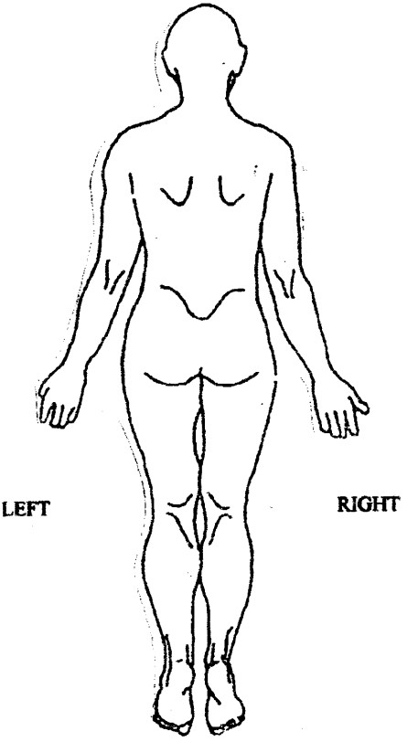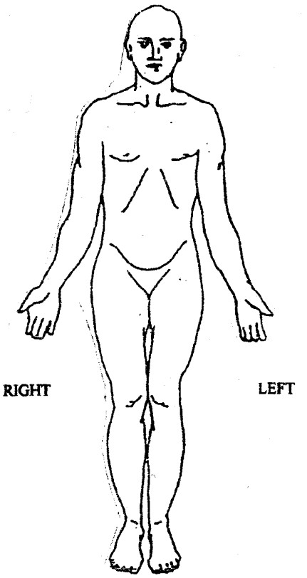
C: COMMENTS
Signature: ____________________________ Name (PRINT): ____________________ Date: ___________________

