docxRisk Assessment - Service User - Falls & Mobility
CP5
Care 24/7 Healthcare Limited
Address: 1-3, MAP House, St Leonards Road, Eastbourne, BN21 3UT
T:
01323 370232 |
E:
info@care247healthcare.co.uk
W:
www.care247healthcare.co.uk | Registration Number: 09909827
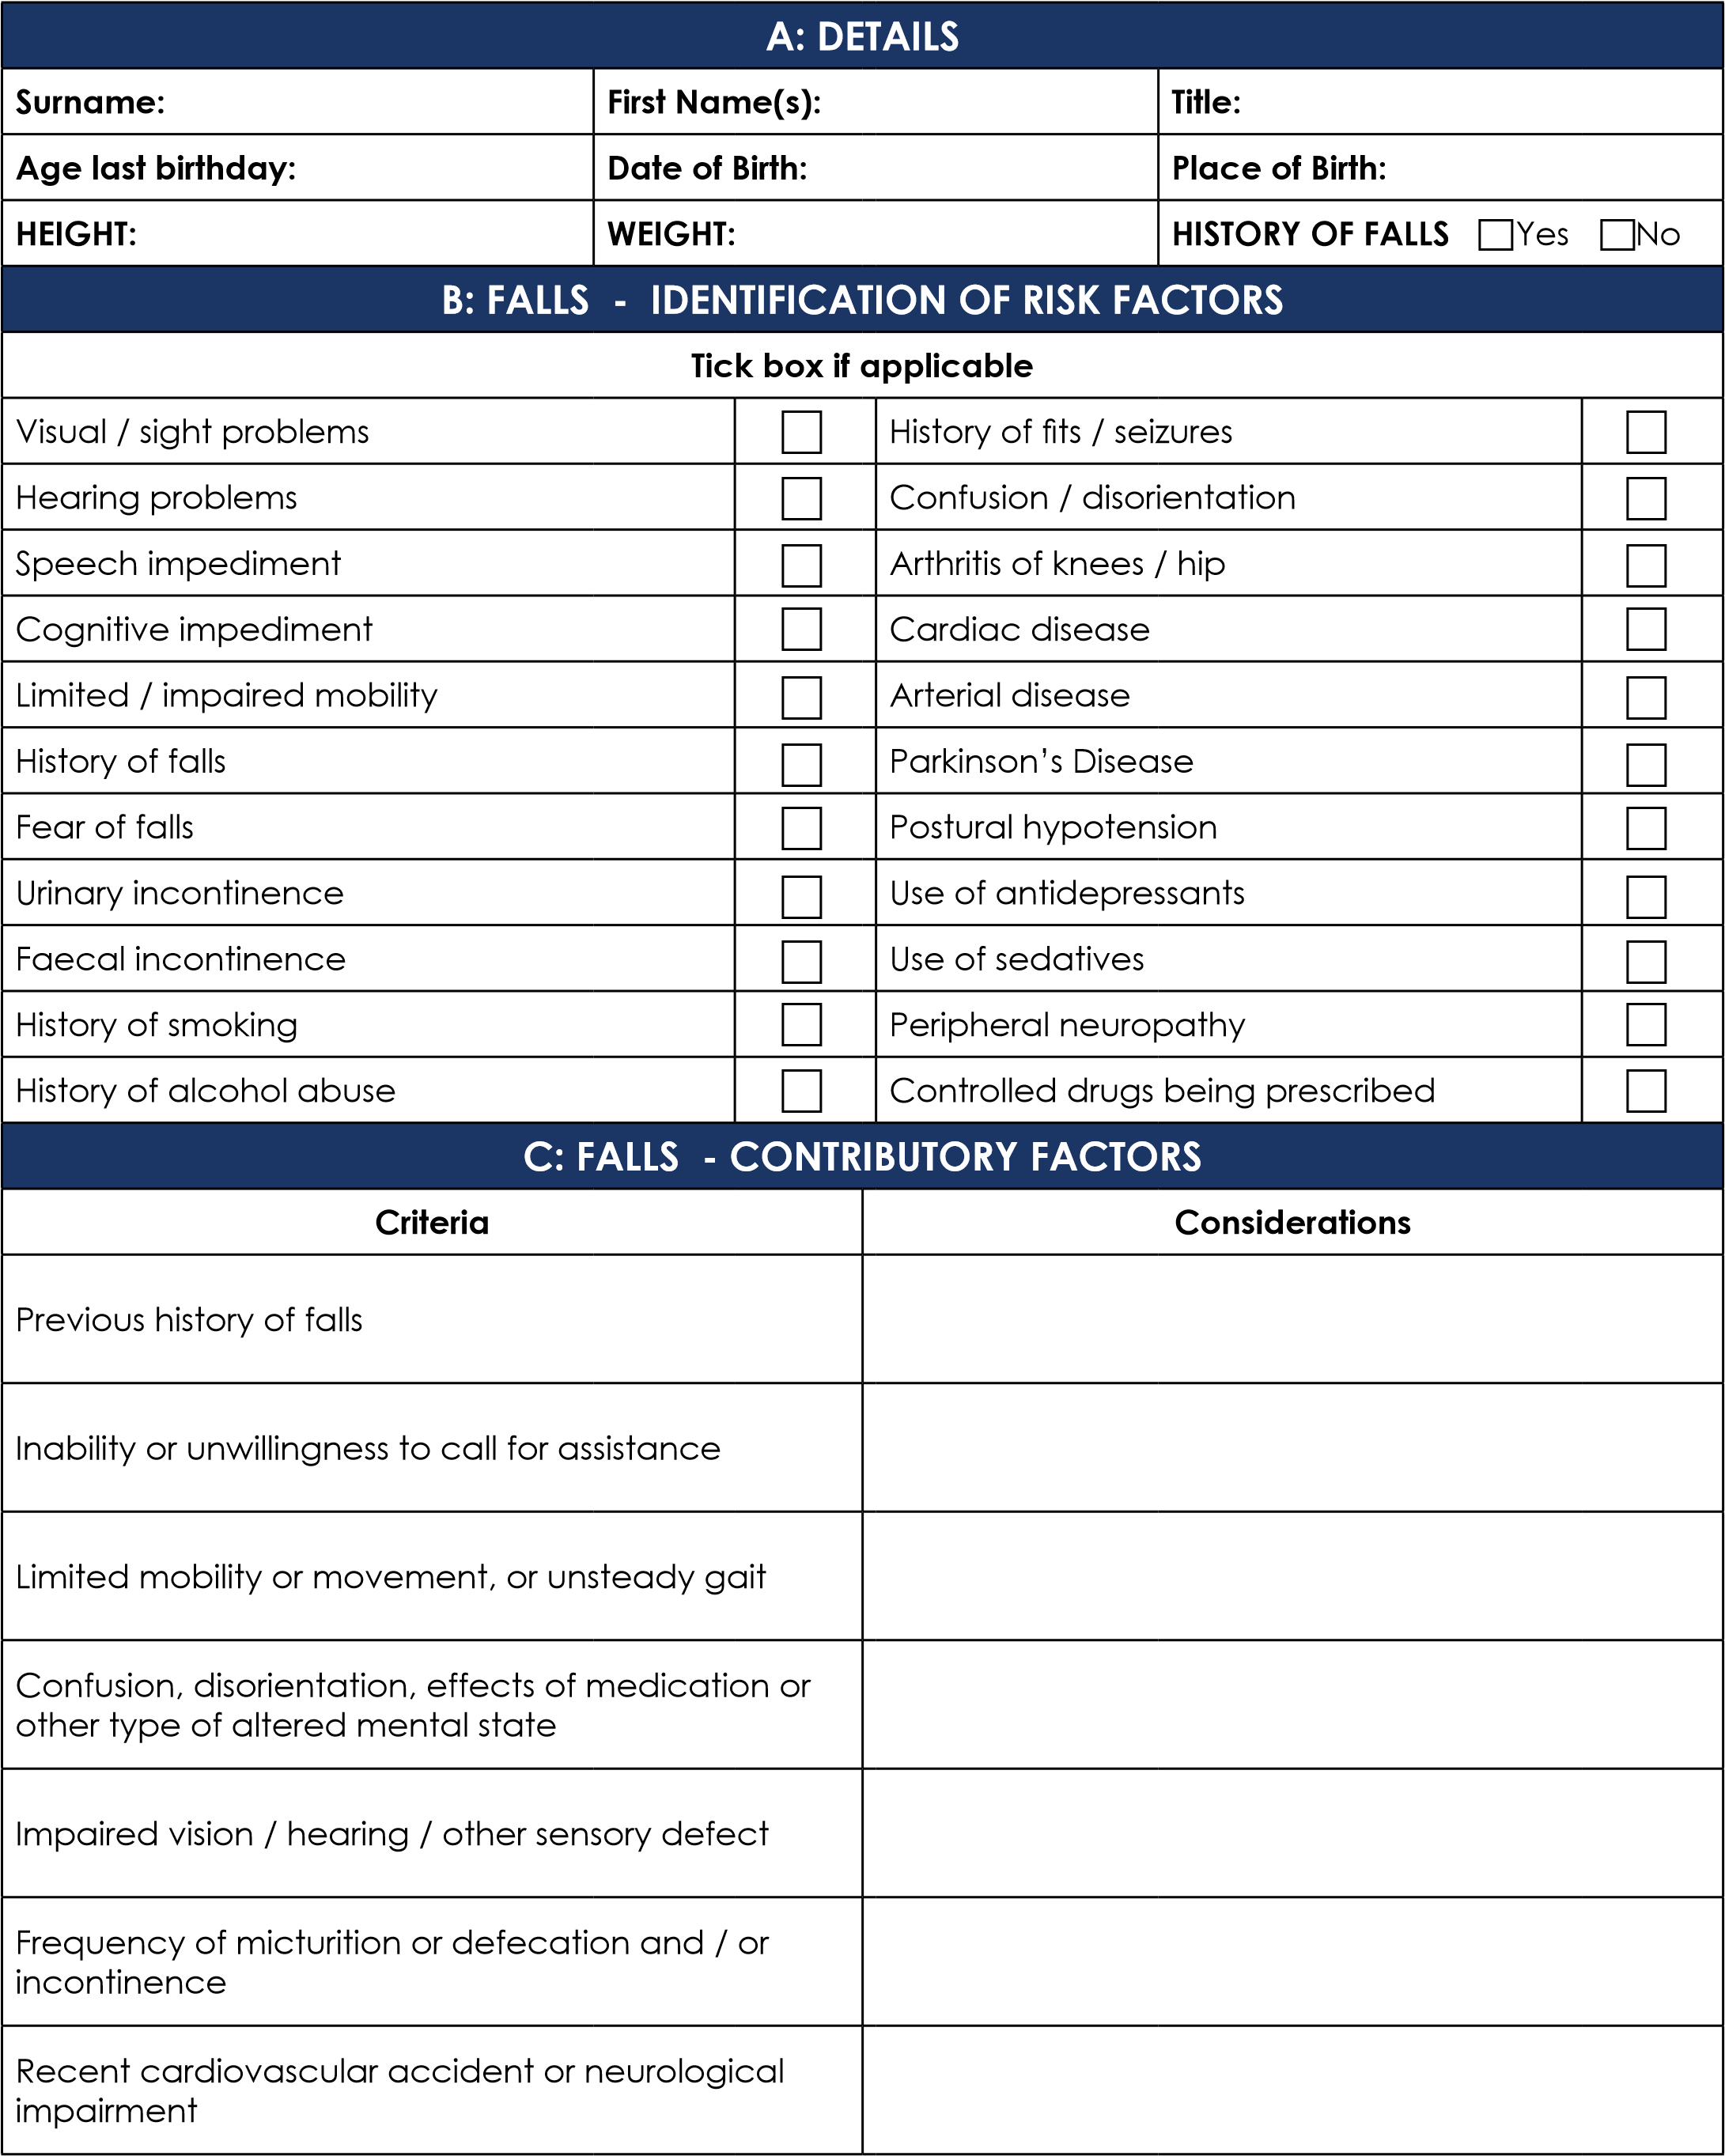

D: EASE OF MOBILITY / MOVEMENT
Activity |  | Normal Capabilities |  | Abnormal Capabilities | Aids Used
Rising from chair
Stand for approx. 30 seconds after rising
Stand with eyes closed for 15 seconds
Walking - distance of 15 feet and back
Walking - distance of 5 feet and turn around
Sitting down in a chair
Negotiating stairs / steps
Going to bed
Rising from bed
In bed - need for bed rails
Toileting
Washing
Showering / bathing
Feeding
E: GENERAL SAFETY AWARENESS
Smoking | Smokes in own home
Smoking | Discarding cigarette butts / use of ashtrays
Going Out | Sense of danger
Going Out | Sense of time
Going Out | Sense of location
Going Out | Sense of direction
Electricity | Can reach power points easily
Electricity | Can reach & manipulate light / lamp switches easily
Electricity | Can reach telephone easily
Electricity | Sense of danger (overloading power points etc)

F: AIDS TO DAILY LIVING
Tick box if applicable
False teeth |  |  |  |  | Walking stick
Spectacles |  |  |  |  | Zimmer frame
Contact lenses |  |  |  |  | Wheelchair
Hearing aid |  |  |  |  | Bed rails
G: COMMENTS, OBSERVATIONS & RECOMMENDATIONS
G: COMMENTS, OBSERVATIONS & RECOMMENDATIONS
INDIVIDUAL | SIGNATURE |  |  |  |  | DATE
Staff member undertaking Assessment:
Service User (or advocate):
Relative / Family Member (as appropriate):
GP / Registered Nurse (as appropriate):
OTHER (specify):

