Choking Risk Assessment - Service User Eating & Drinking
Service User:_________________________________ Date of Birth: __________________________
NF16
Care 24/7 Healthcare Limited
Address: 1-3, MAP House, St Leonards Road, Eastbourne, BN21 3UT
T:
01323 370232 |
E:
info@care247healthcare.co.uk

W:
www.care247healthcare.co.uk | Registration Number: 09909827
Complete this Form by ticking the relevant boxes each time you suspect a service user is having difficulties eating and drinking.
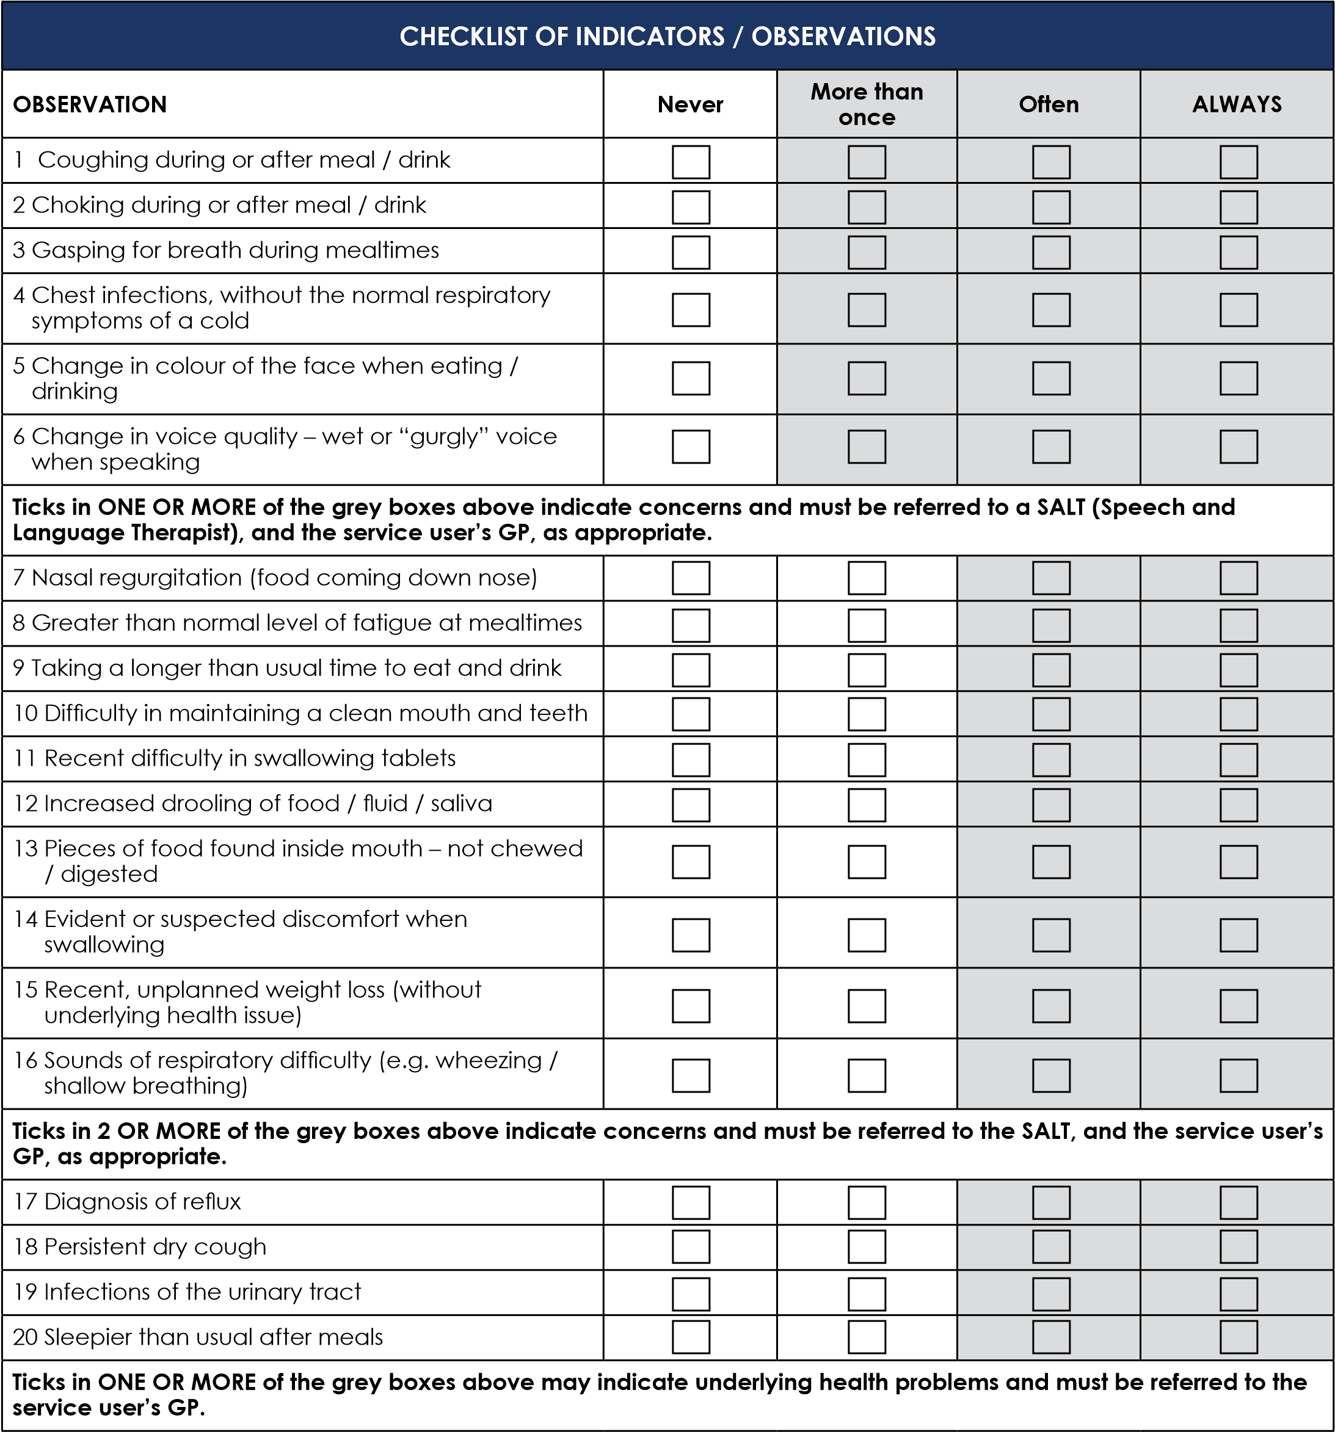

COMMENTS & ACTION TAKEN:
Signature: ________________________ Name: _______________________ Date: _____________

