Pain Assessment Chart
CC1
Service User: ___________________________________________ Reference: ____________________________ Date of Assessment: _________________________________
Care 24/7 Healthcare Limited
Address: 1-3, MAP House, St Leonards Road, Eastbourne, BN21 3UT
T:
01323 370232 |
E:
info@care247healthcare.co.uk
W:
www.care247healthcare.co.uk | Registration Number: 09909827
A: DESCRIPTIVE DETAILS |  | DESCRIPTIVE WORDS  Throbbing  Cutting  Burning  Stinging  Aching  Tiring  Blinding  Intense  Penetrating  Nagging  Shooting  Gnawing  Searing  Dull | Squeezing  Annoying  Unbearable  Radiating  Nauseating  Stabbing  Crushing  Smarting  Hurting  Splitting  Sore  Miserable  Spreading  Piercing
Can you describe the pain?
What makes the pain worse?
What makes the pain better?
Tender Torturing
Comfortable Pain-free
Coping Relaxed
Electric Shock Happy
Discomfort Content
1
Service User: ___________________________________________ Reference: ____________________________ Date of Assessment: _________________________________
 | 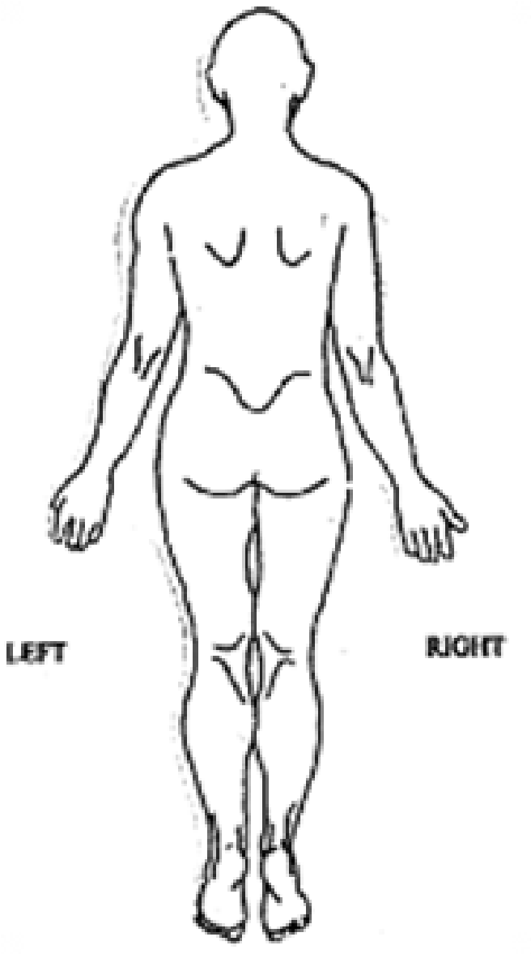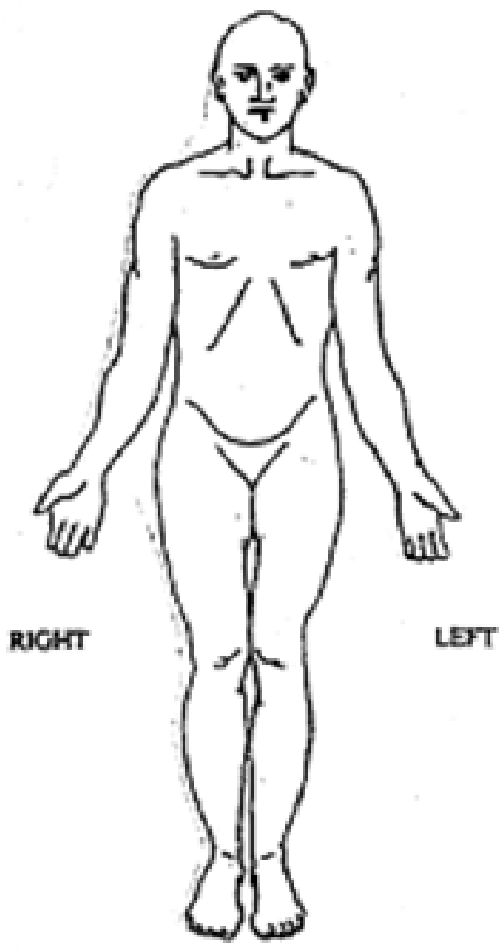  2  WHERE IS THE PAIN?  (  Mark with “A”, “B”, “C” etc  )  0 1 2 3 4 5 6 7 8 9 10  NONE  SEVERE
  A: DESCRIPTIVE DETAILS
  Date | EVALUATION | Signature

