Wound Assessment & Treatment
CC4
Care 24/7 Healthcare Limited
Address: 1-3, MAP House, St Leonards Road, Eastbourne, BN21 3UT
T:
01323 370232 |
E:
info@care247healthcare.co.uk
W:
www.care247healthcare.co.uk | Registration Number: 09909827
 | A: PERSONAL DETAILS OF SERVICE USER
Surname: |  | First Name(s): | Likes to be known as:
Age last birthday: |  | Date of Birth: | Service User’s GP:
 | B: DETAILS OF WOUND
TYPE OF WOUND
ASSOCIATED CLINICAL PROBLEMS
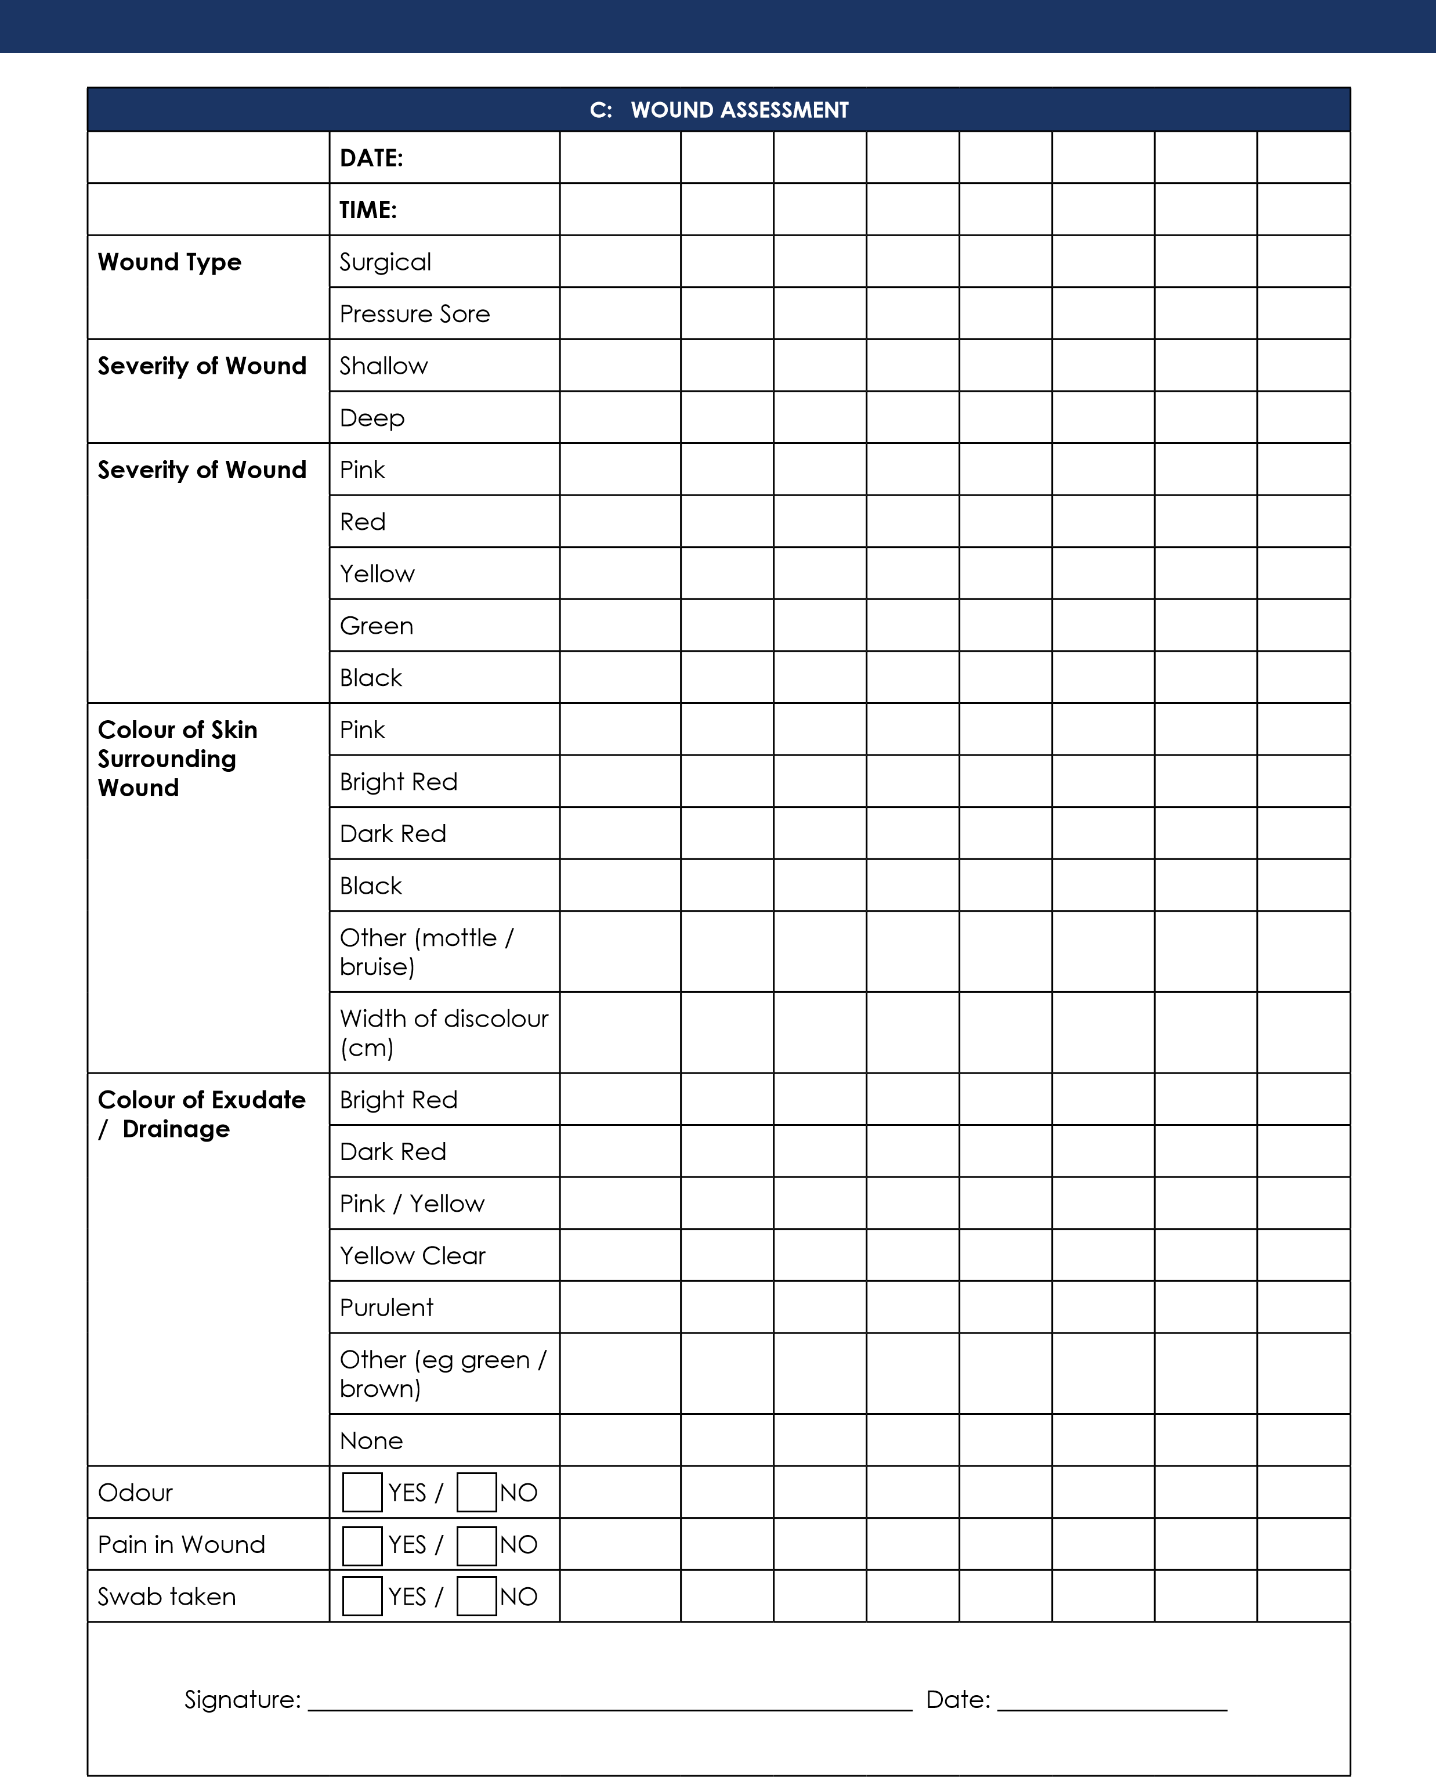

D: WOUND TREATMENT RECORD
Wound to be assessed at EVERY dressing change
WOUND CLEANING PROCEDURE:  Product(s) |  |  | Method:
WOUND DEBRIDEMENT PROCEDURE:  Product(s) |  |  | Method:
MEDICAMENTS APPLIED TO WOUND:  Product(s) |  |  | Method:
PRIMARY WOUND CONTACT PRODUCT: | Application Details: |  | Size: |  | Number Used:
SECONDARY DRESSING and / or FIXATURE: | Application Details: |  | Size: |  | Number Used:
FREQUENCY OF DRESSING CHANGES  Specify how often dressing to be changed: |  |  | CARER SIGN & DATE:  Signature: _____________________ Date: _____________
E: RECORD OF DRESSING CHANGES
Date:
Carer Signature:
REVIEW DATE:
CARER SIGNATURE:
Date CHART DISCONTINUED:
Comments / Observations:
Signature: ________________________________________________ Date: ____________________________

