End-of-Life Care Strategy - Maintenance of Service User Health & Assessment of Needs
EC2
Care 24/7 Healthcare Limited
Address: 1-3, MAP House, St Leonards Road, Eastbourne, BN21 3UT
T:
01323 370232 |
E:
info@care247healthcare.co.uk
W:
www.care247healthcare.co.uk | Registration Number: 09909827
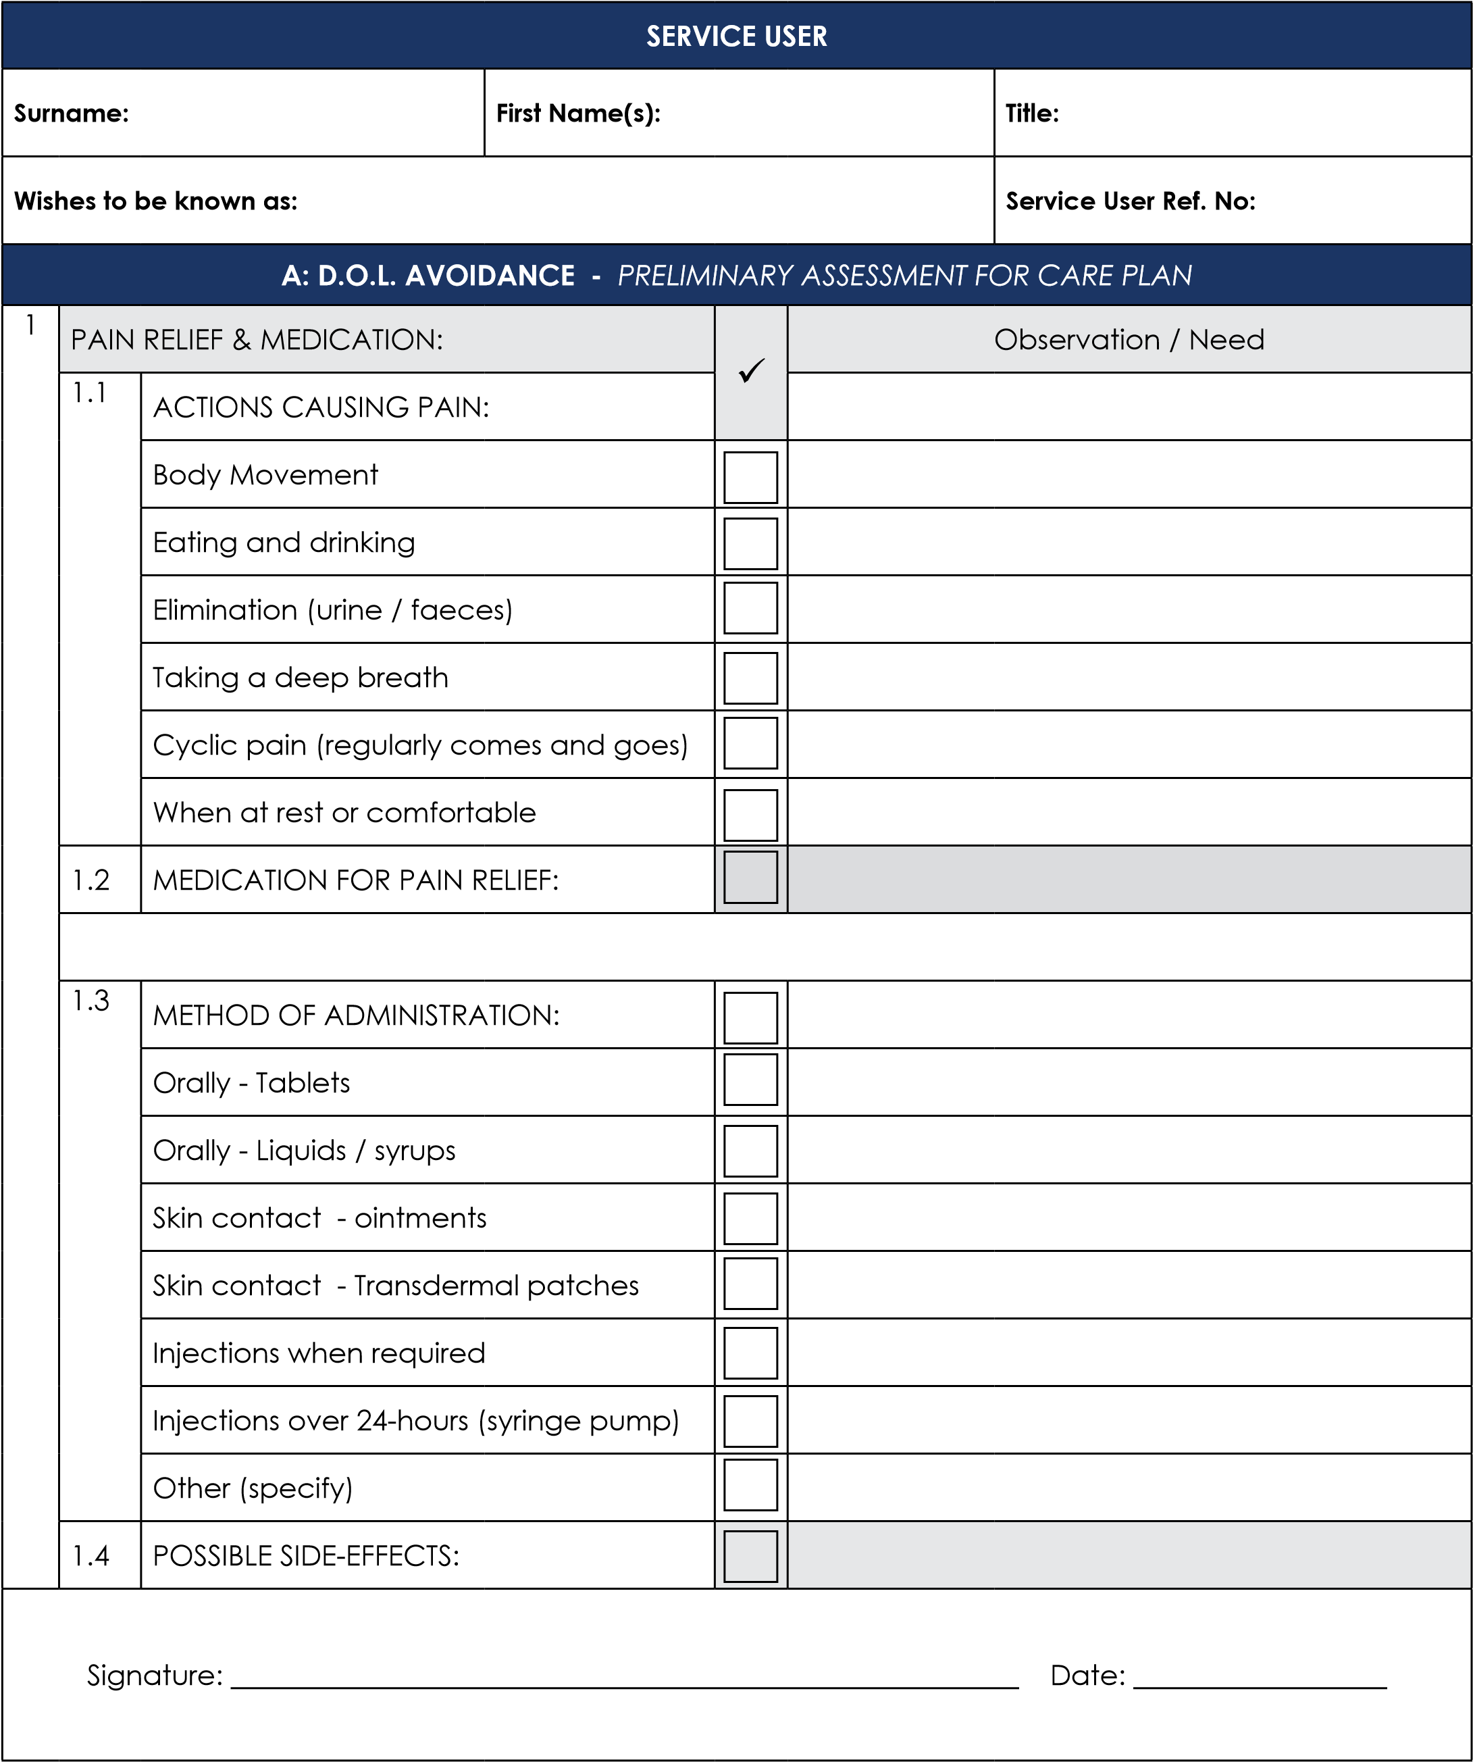
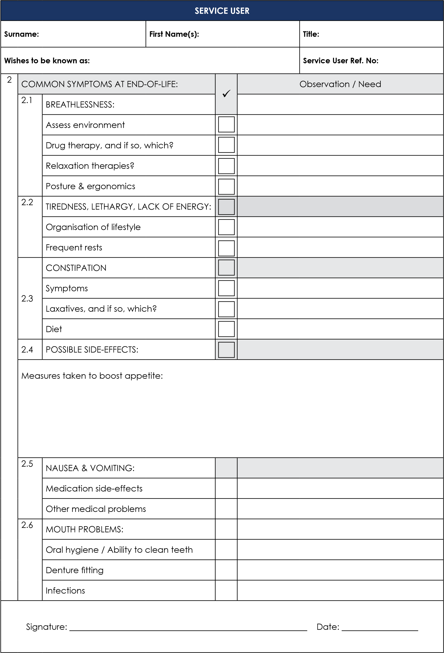

SERVICE USER
Surname: |  |  | First Name(s): |  |  |  | Title:
Wishes to be known as: |  |  |  |  |  |  | Service User Ref. No:
3 | EATING & DRINKING: |  |  |  |  | Observation / Need
3 | 3.1 | PHYSIOLOGICAL: |  | ✓
3 | 3.1 | Mouth problems
3 | 3.1 | Constipation
3 | 3.1 | Infections
3 | 3.1 | Depressed / frightened / tired
3 | 3.1 | Medication depressing appetite
3 | 3.1 | Pain depressing appetite
3 | 3.1 | Problems sudden or gradual?
3 | 3.2 | DIFFICULTIES IN EATING OR DRINKING:
3 | 3.2 | Takes a long time to finish a meal
3 | 3.2 | Lack of oral control (food dribbles etc)
3 | 3.2 | Stores food in the mouth
3 | 3.2 | Coughing / spluttering during or after meal
3 | 3.3 | ENVIRONMENT:
3 | 3.3 | Noisy
3 | 3.3 | Crowded / lack of privacy
3 | 3.3 | Comfortable sitting position
3 | 3.3 | Right amount of physical support
3 | 3.3 | Reliance upon special cutlery / crockery
3 | 3.4 | FOOD QUALITY & QUANTITY:
3 | 3.4 | Portions too large or too small
3 | 3.4 | Food looks / smells appetising
3 | 3.4 | Food consistency (puree, cut up small etc)
Signature: ________________________________________________________ Date: __________________

SERVICE USER
Surname: |  |  | First Name(s): |  |  |  | Title:
Wishes to be known as: |  |  |  |  |  |  | Service User Ref. No:
4 | MOBILITY: |  |  |  |  | Observation / Need
4 | 4.1 | RELUCTANCE TO MOVE ABOUT: |  | ✓
4 | 4.1 | Sensory problems
4 | 4.1 | Recent trauma
4 | 4.1 | Physical disabilities (arthritis, etc)
4 | 4.1 | Infection
4 | 4.1 | Medication affecting balance / movement
4 | 4.1 | Depressed / frightened / confused
4 | 4.1 | Breathlessness when moving
4 | 4.2 | DIFFICULTIES IN MOVING:
4 | 4.2 | Long time to walk a short distance
4 | 4.2 | Limps or other mannerisms when walking
4 | 4.2 | Staggering / losing balance
4 | 4.2 | Walks around unseen objects on floor
4 | 4.2 | Hesitates at changes in floor surfaces
4 | 4.2 | Bumps into doors or walls
4 | 4.3 | ENVIRONMENT:
4 | 4.3 | Noisy
4 | 4.3 | Crowded / lack of privacy
4 | 4.3 | Chair at right height to get out of
4 | 4.3 | Wearing suitable footwear
4 | 4.3 | Flooring surfaces
4 | 4.3 | Walking aids
4 | 4.3 | Ambient temperature too hot or too cold
Signature: ________________________________________________________ Date: __________________

SERVICE USER
Surname: |  |  | First Name(s): |  |  |  | Title:
Wishes to be known as: |  |  |  |  |  |  | Service User Ref. No:
5 | COMPLEMENTARY THERAPIES: |  |  |  |  | Observation / Need
 |  |  |  | ✓
 | 5.1 | TYPES OF THERAPY:
 | 5.1 | Reflexology
 | 5.1 | Acupuncture
 | 5.1 | Aromatherapy
 | 5.1 | Hypnotherapy
 | 5.1 | Relaxation techniques
 | 5.1 | Homeopathy
 | 5.1 | Meditation
 | 5.1 | Visualisation
 | 5.2 | POSSIBLE EFFECTS:
 | 5.2 | Relaxation of muscles?
 | 5.2 | Relief of constipation or other symptoms?
 | 5.2 | Anxiety reduction?
 | 5.2 | Circulation improved?
 | 5.2 | Promotion of a felling of well-being?
 | 5.2 | Reduction in stress?
Signature: ________________________________________________________ Date: __________________

