Risk Assessment - Child & Environment
SR8
Care 24/7 Healthcare Limited
Address: 1-3, MAP House, St Leonards Road, Eastbourne, BN21 3UT
T:
01323 370232 |
E:
info@care247healthcare.co.uk
W:
www.care247healthcare.co.uk | Registration Number: 09909827
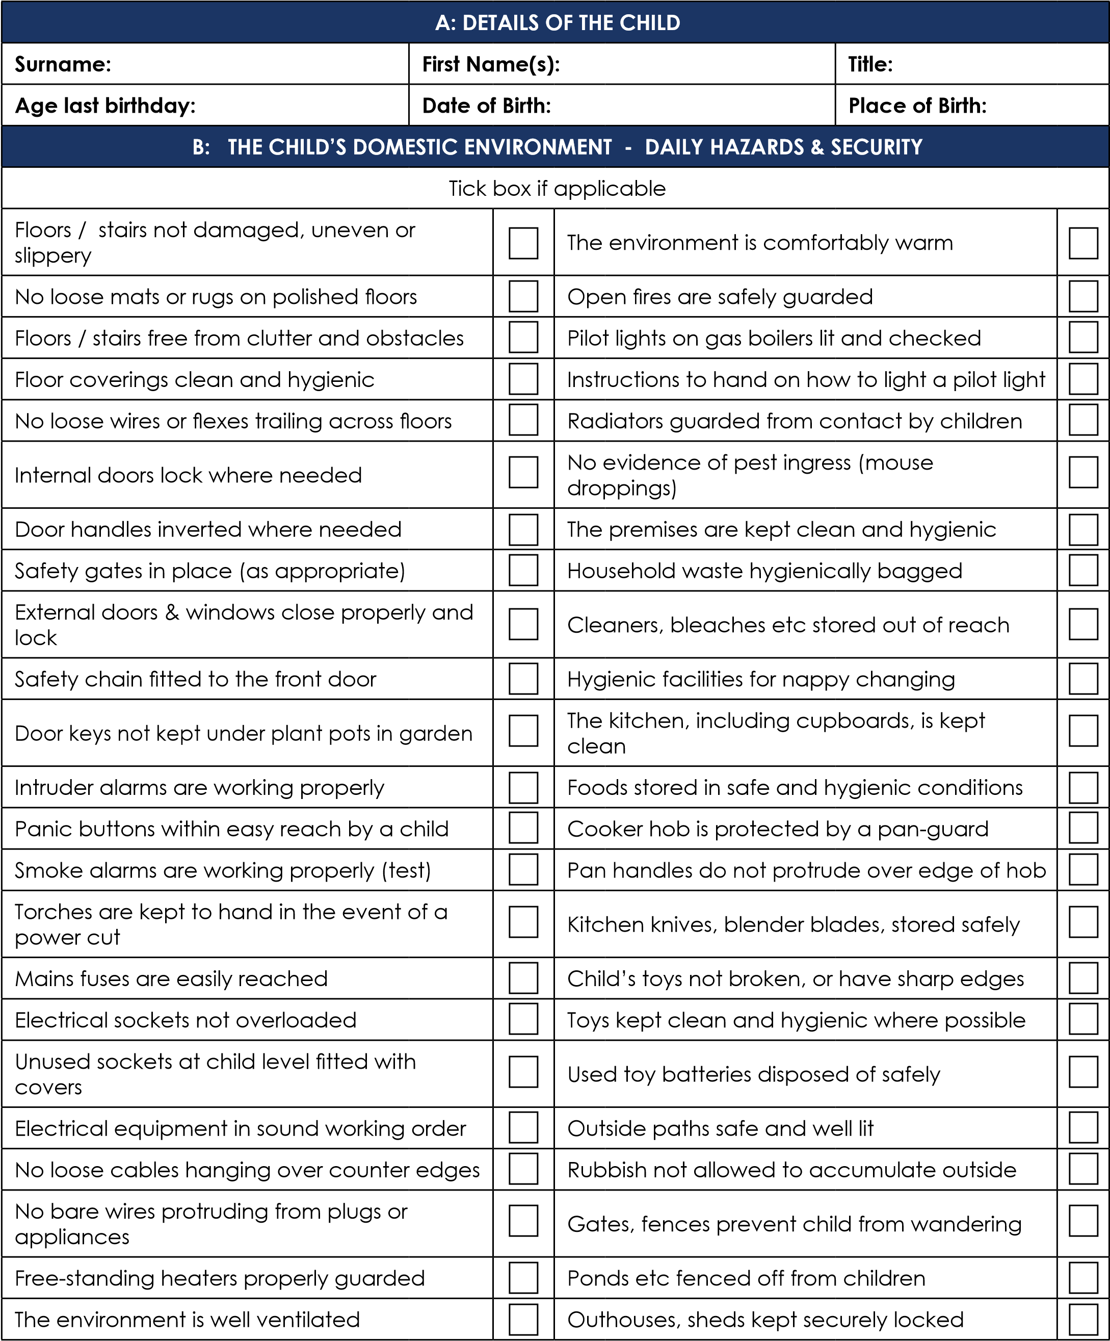

C: CLINICAL CONSIDERATIONS / VULNERABILITY OF THE CHILD
Tick box if applicable
Child has visual / sight problems |  |  | Child has unrestricted access to the internet
Child has hearing / audio problems |  |  | Child lives in an abusive relationship
Child has a speech impediment |  |  | Domestic violence issues
Child has a cognitive impediment |  |  | CHILD IS UNDULY VULNERABLE TO ABUSE
Child has limited / impaired mobility |  |  | CHILD ABUSE SUSPECTED
Child has a history of fits / seizures |  |  | Child is on a regimen of prescribed medication
Urinary incontinence in the older child |  |  | Controlled drugs being prescribed
Faecal incontinence in the older child |  |  | Drugs not stored securely away from the child
Child lives in a clean / hygienic environment |  |  | Child has special dietary needs (specify)
Child’s clothing is clean |  |  | Child has regular nourishing meals
Child lives in a smoking environment |  |  | No indicators of malnourishment / dehydration
Child lives in an environment of drug abuse |  |  | No indicators of obesity issues
Child lives in an environment of alcohol abuse |  |  | Child has adequate access to drinks / fluids
D: COMMENTS, OBSERVATIONS & RECOMMENDATIONS
E: SIGNATORIES
INDIVIDUAL | SIGNATURE |  |  | DATE
Staff member undertaking Assessment:
Service User (Family Member):
Relative / other Family Member (as appropriate):
GP / Registered Nurse (as appropriate):
OTHER (specify):

