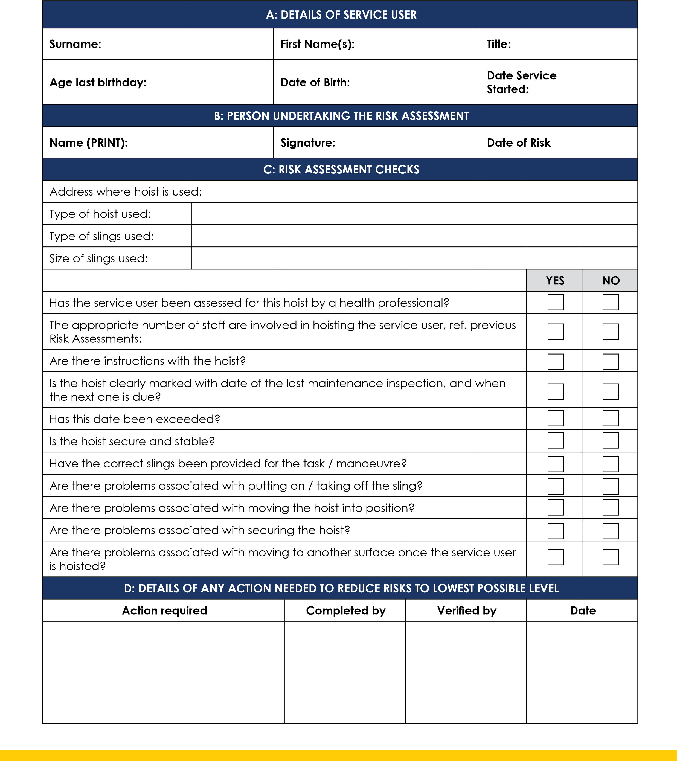
Risk Assessment - Hoists
OHS5
Care 24/7 Healthcare Limited
Address: 1-3, MAP House, St Leonards Road, Eastbourne, BN21 3UT
T:
01323 370232 |
E:
info@care247healthcare.co.uk
W:
www.care247healthcare.co.uk | Registration Number: 09909827

