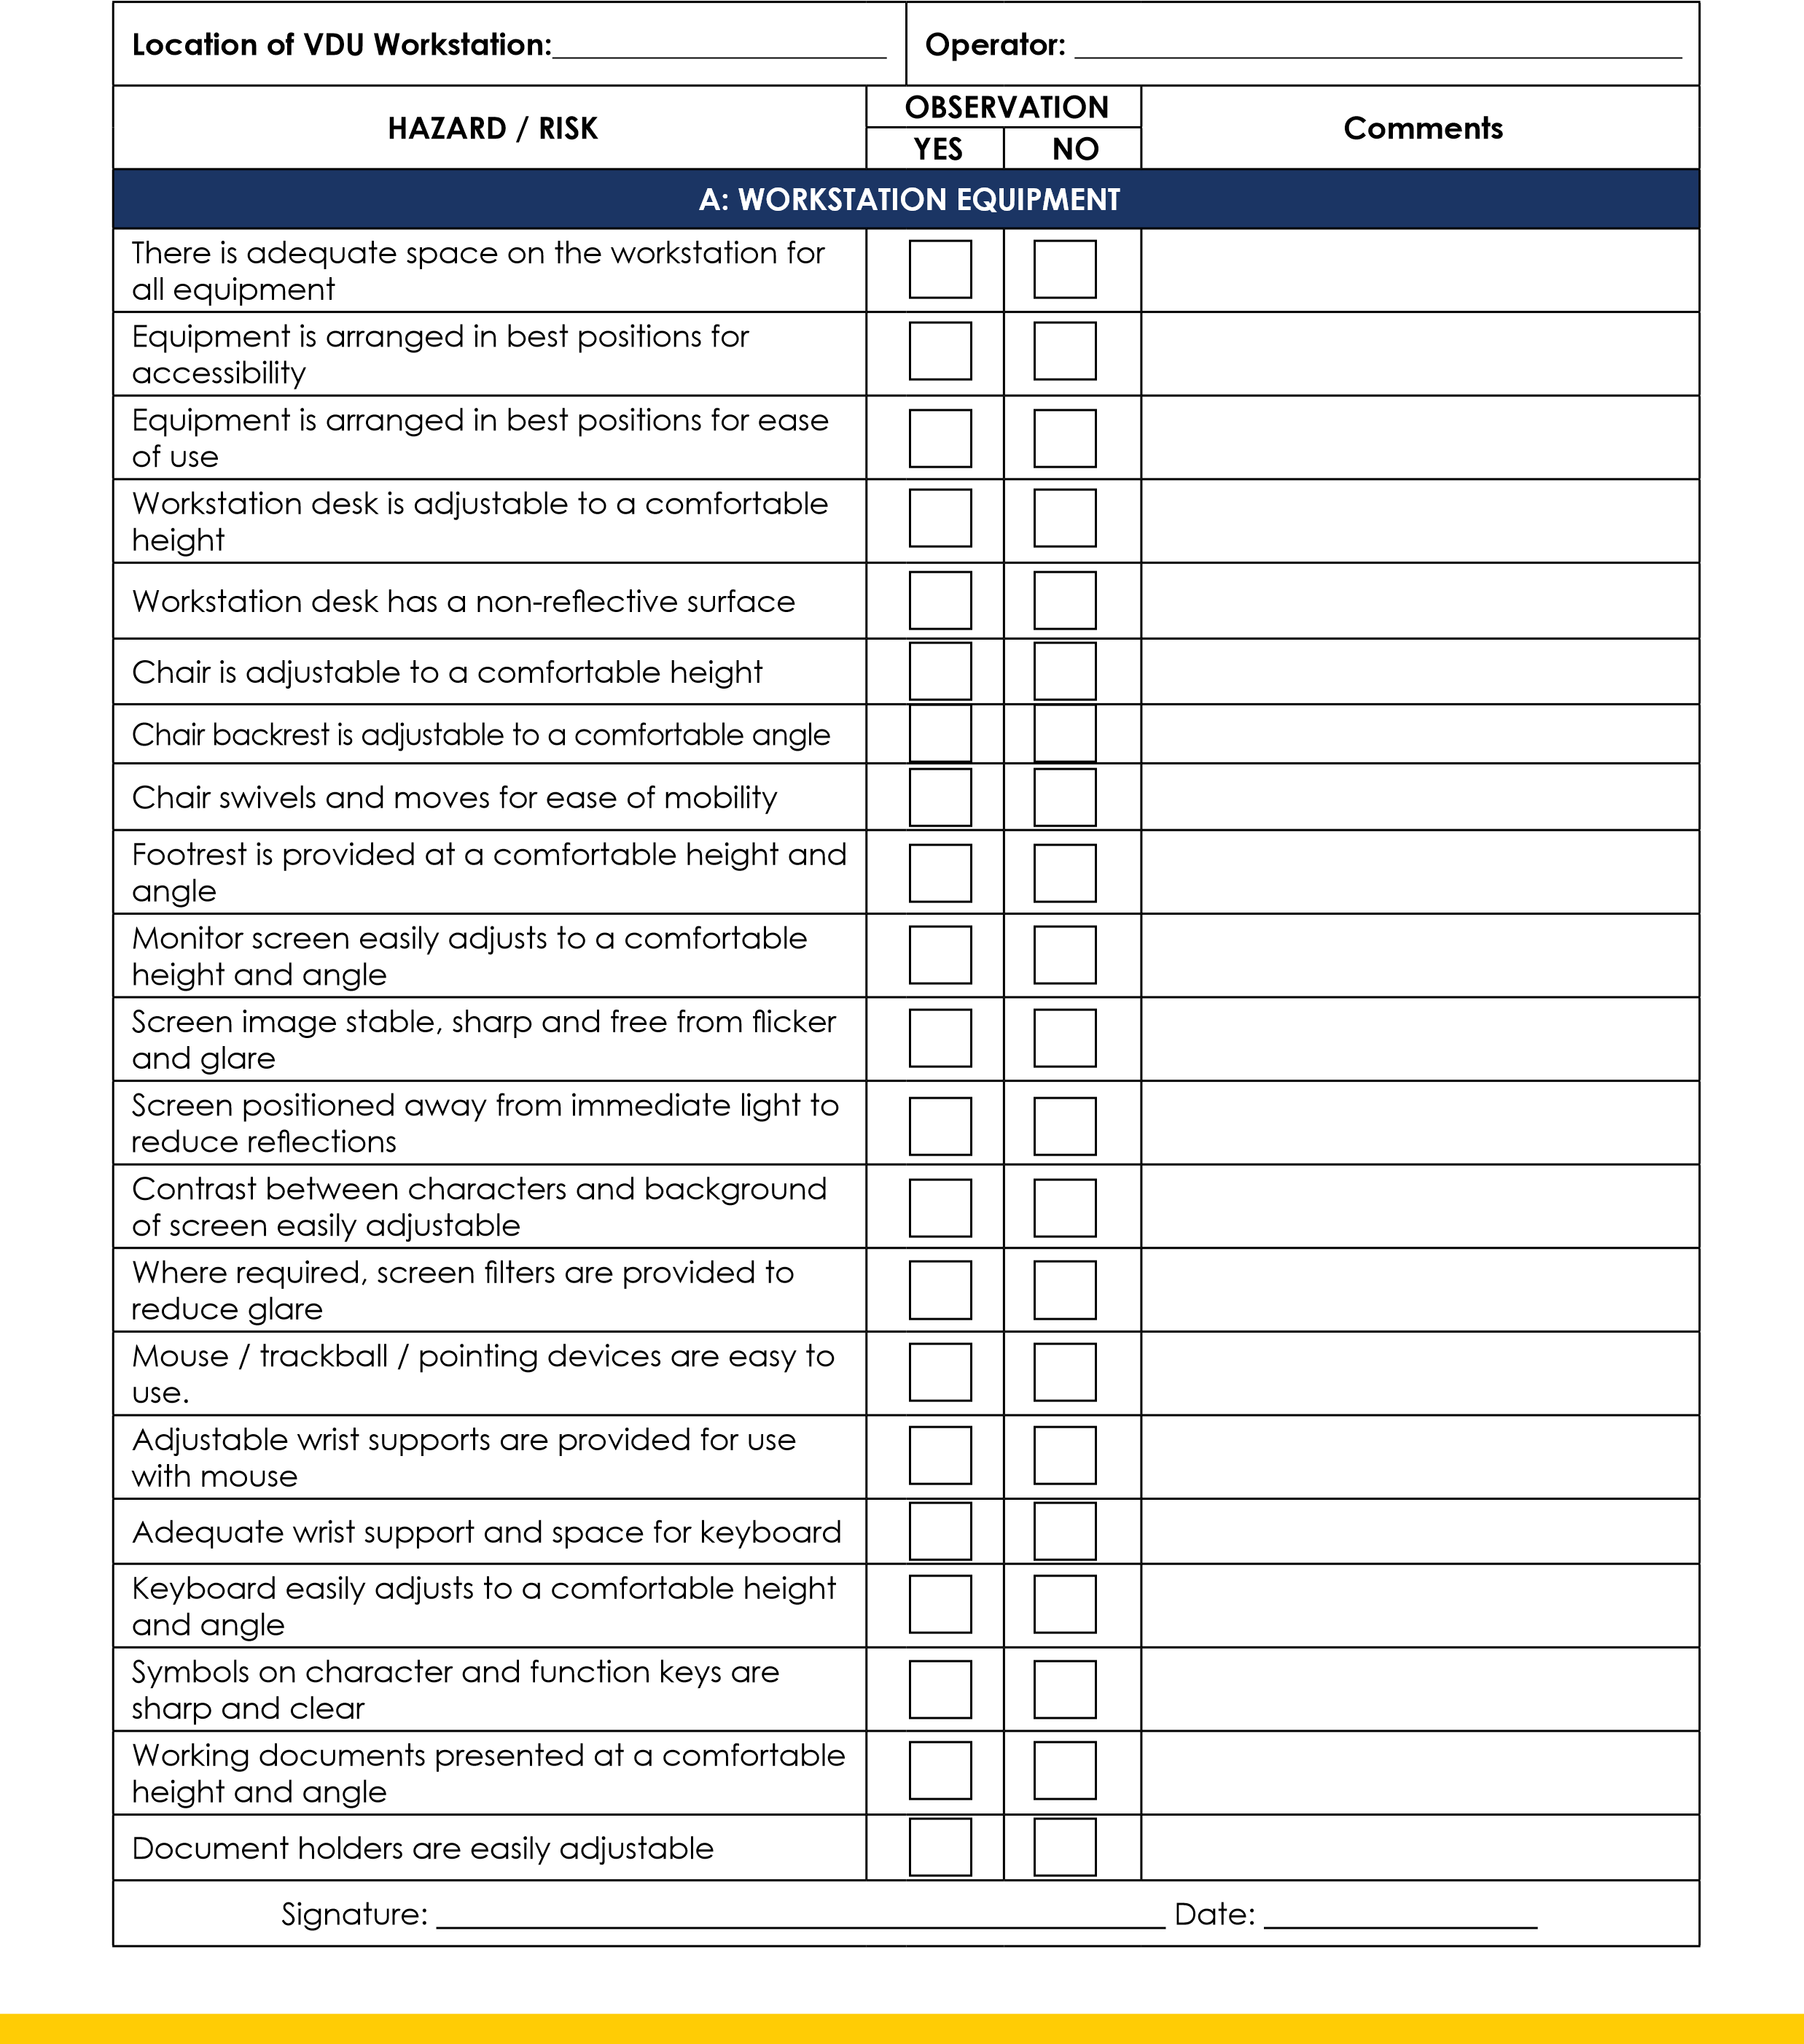
Risk Assessment - VDU Workstations
OHS7
Care 24/7 Healthcare Limited
Address: 1-3, MAP House, St Leonards Road, Eastbourne, BN21 3UT
T:
01323 370232 |
E:
info@care247healthcare.co.uk
W:
www.care247healthcare.co.uk | Registration Number: 09909827

HAZARD / RISK | OBSERVATION |  | Comments
HAZARD / RISK | YES | NO | Comments
B: WORKSTATION ENVIRONMENT
Overall lighting at the workstation at an acceptable level
Local lighting (desk-top lamps etc) provided where required
Temperatures at the workstation at an acceptable level
Humidity at the workstation at an acceptable level
Workstation is adequately separated from other workstations
There is a low level of environmental noise around the workstation workstation
C: STAFF TRAINING & WELFARE
Staff trained in correct ergonomic use of VDU equipment
Staff receive specialist training in software products
Staff are provided with opportunities for regular eyesight tests
Staff are provided with opportunities for regular eye checks
Signature: ________________________________________________ Date: __________________

