Risk Assessment - Staff Working Late or Alone
SHS3
Care 24/7 Healthcare Limited
Address: 1-3, MAP House, St Leonards Road, Eastbourne, BN21 3UT
T:
01323 370232 |
E:
info@care247healthcare.co.uk

W:
www.care247healthcare.co.uk | Registration Number: 09909827
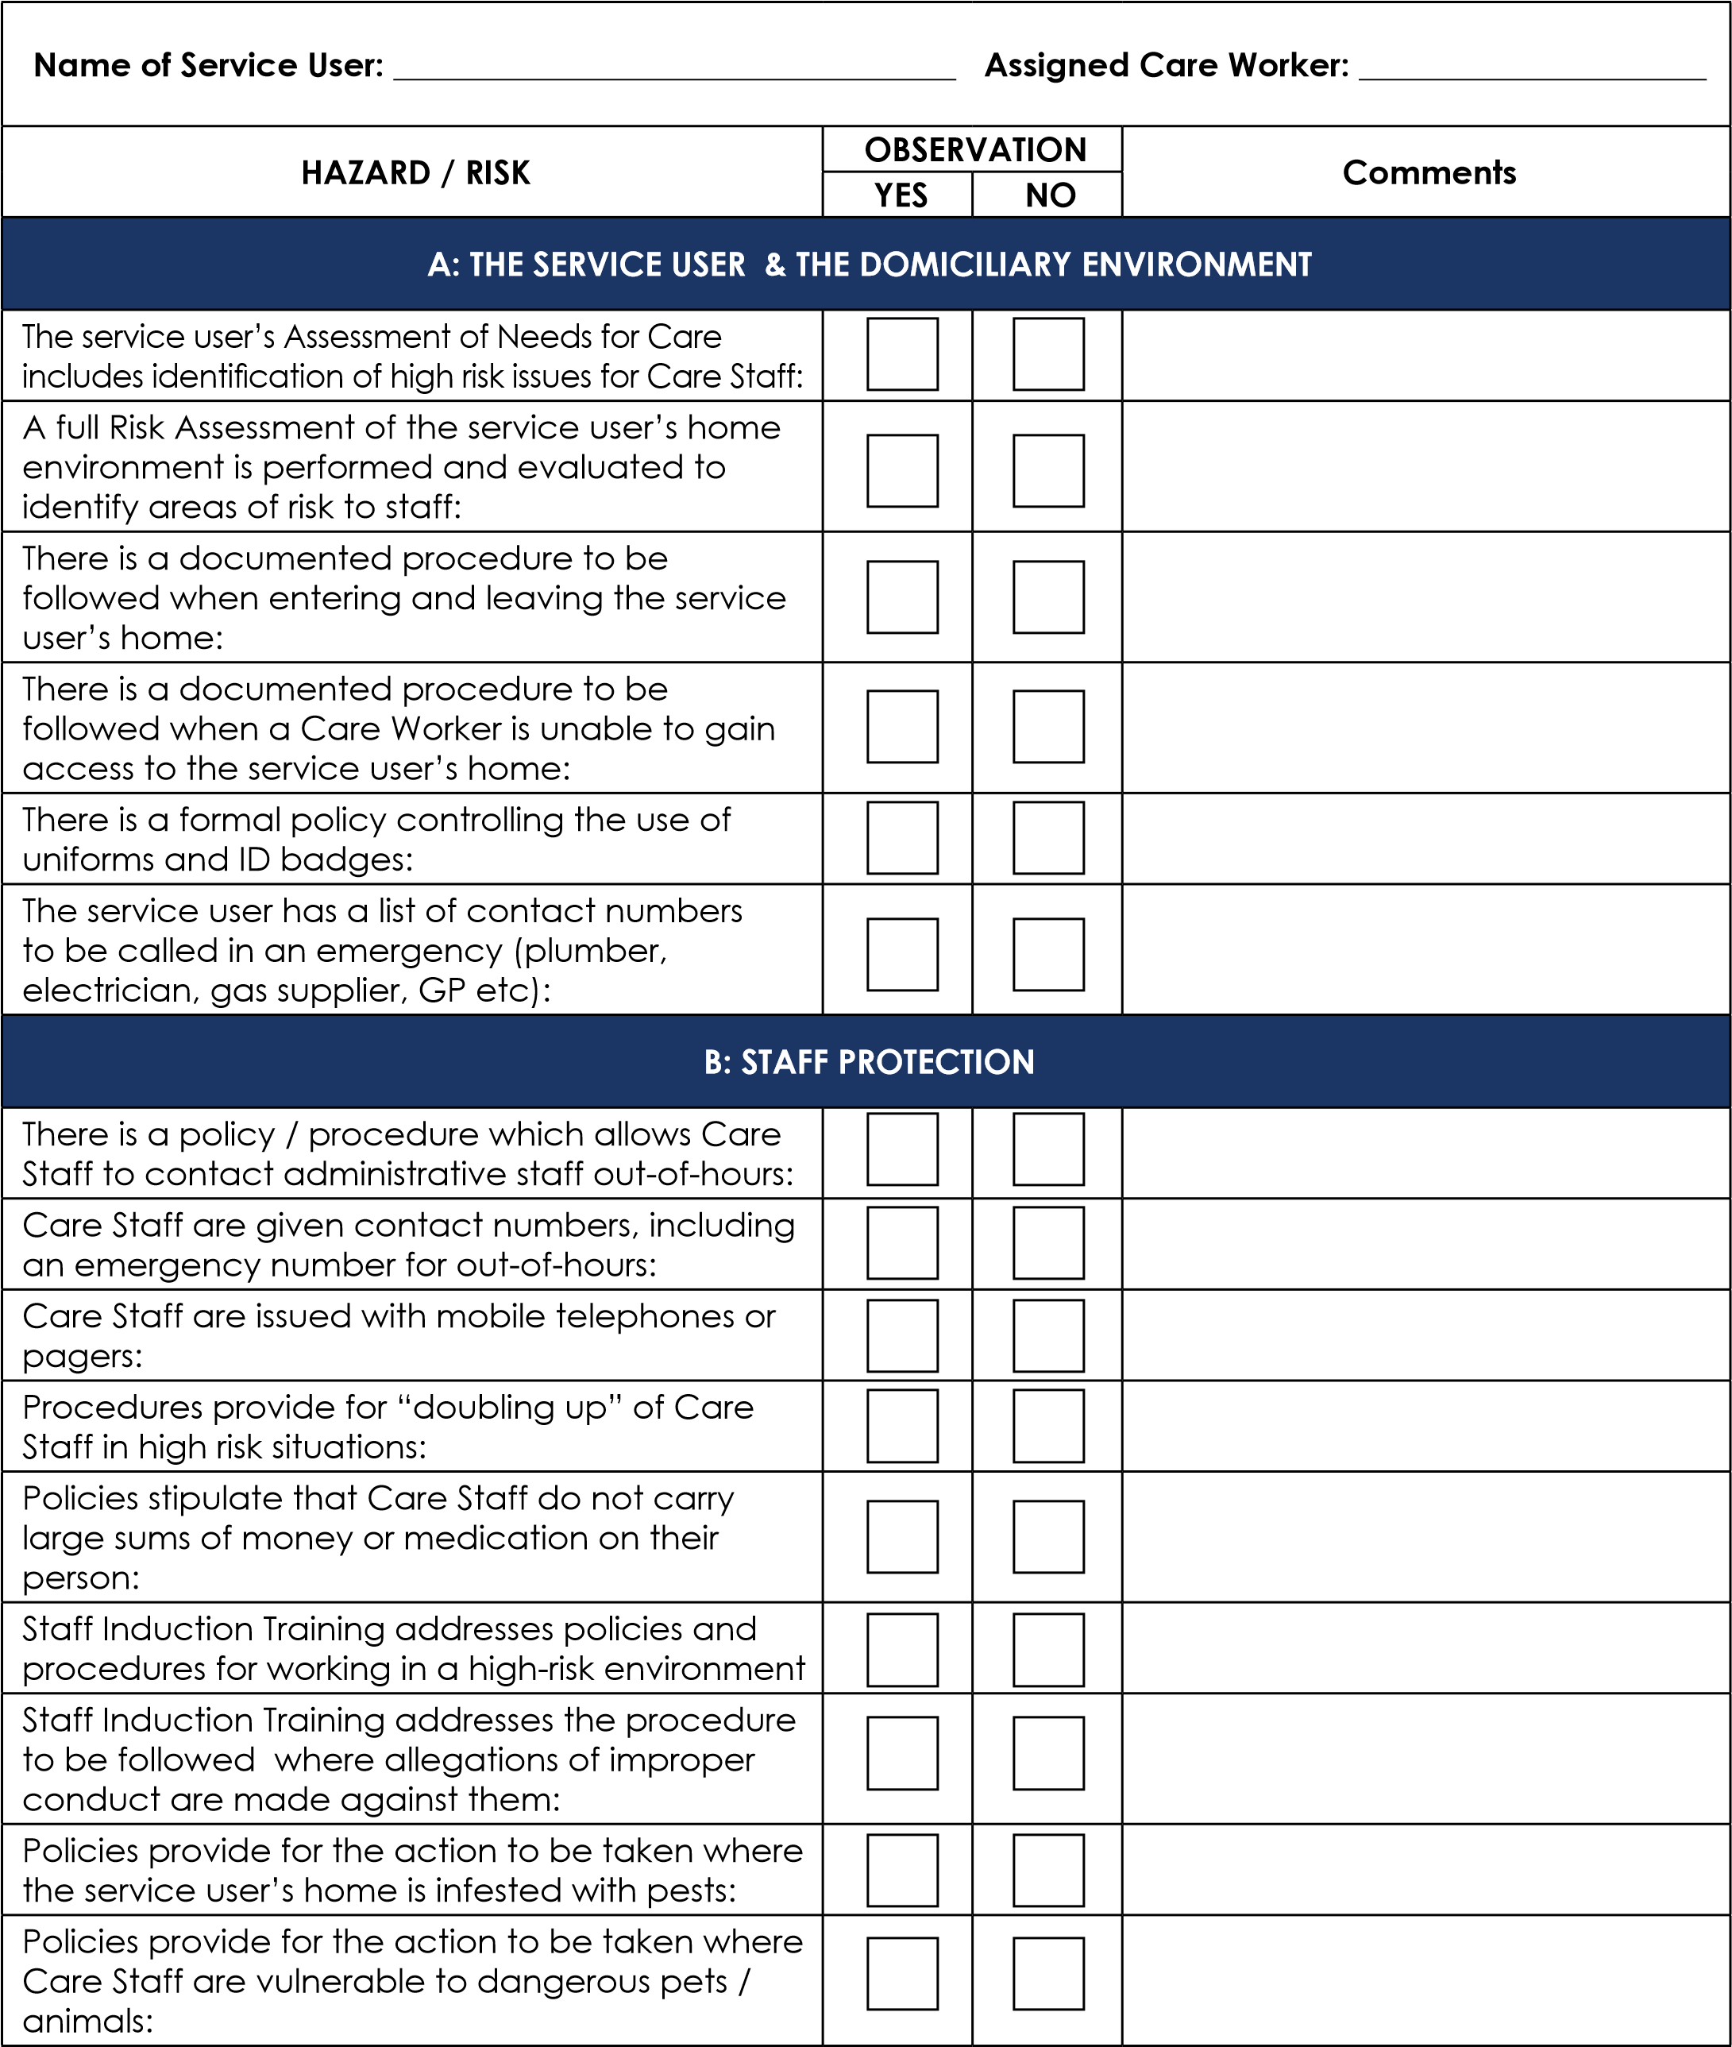

Name of Service User: __________________________________ Assigned Care Worker: _____________________
HAZARD / RISK | OBSERVATION |  |  |  |  |  | Comments
HAZARD / RISK | YES |  |  | NO |  |  | Comments
Policies provide for the action to be taken in the event of the Care Worker being subjected to harassment or abuse by the service user:
Policies provide for withdrawal of the Care Service under appropriate circumstances, and the action to be taken:
C: EMERGENCY SITUATIONS
There is a policy / procedure for handling accidents to staff while working at the service user’s home:
There is a policy / procedure for handling breakins and attempted break-ins at the service user’s home:
There is a policy / procedure for handling situations involving bogus callers or other suspicious persons at the service user’s home:
There are emergency policies / procedures for dealing with failure of utility services at the service user’s home (power cut, gas leaks etc):
There is an emergency policy / procedure for dealing with an accident or injury to the service user:
There is an emergency policy / procedure for dealing with sudden illness of the service user:
There is an emergency policy / procedure for dealing with suspected service user hypothermia:
There are emergency policies / procedures for dealing with suspected abuse of the service user, including self-abuse and neglect:

