CARE 24/7
HEALTHCARE Are you looking for traincd hcalthcarc professionals to cover tcmporary, cmergcncy or long-tcrm shifts?
Trust Care 24/7 Healthcare to supply qualified nurses, carers and support staff.

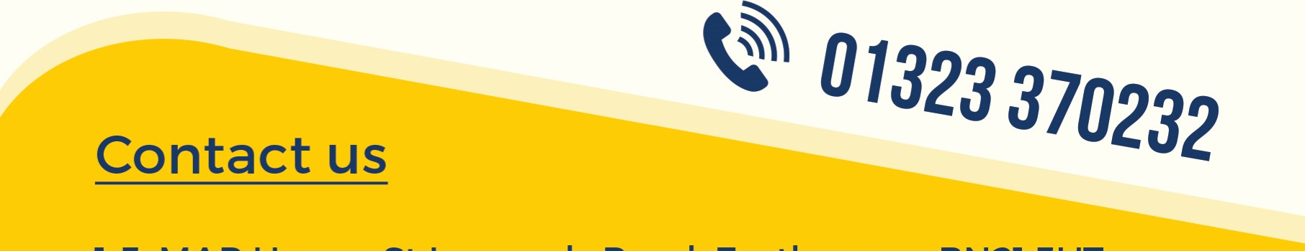
FLEXIBLE EFFICIENT RELIABLE DEPENDABLE COST EFFECTIVE
We are an East Sussex-based agency that supplies highly trained healthcare specialists to organisations just like yours. Find out how we can help you cover any shift, any time, by getting in touch today.
Call us or visit our website for more information.
1-3, MAP House, St Leonards Road, Eastbourne, BN21 3UT info@care247healthcare.co.uk - www.care247healthcare.co.uk

