CARE 24/7
HEALTHCARE Are you looking for healthcarc staff?
Do you have short term, ad hoc or permanent healthcare staffing needs?
Is your establishment in need of qualified professionals at short notice?
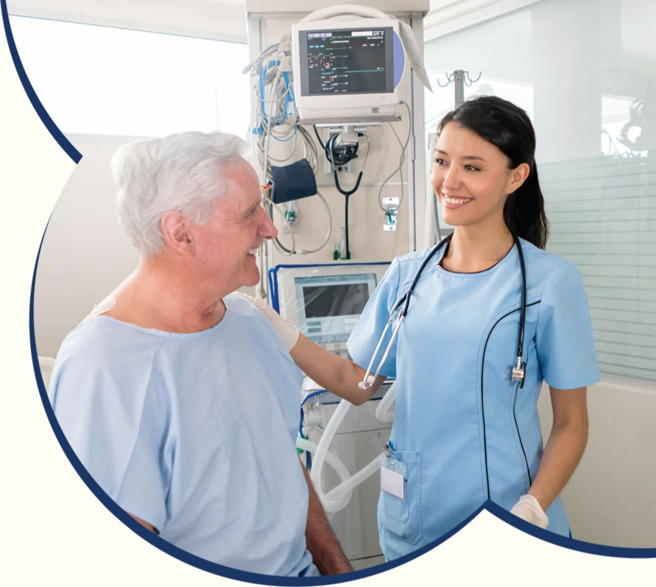

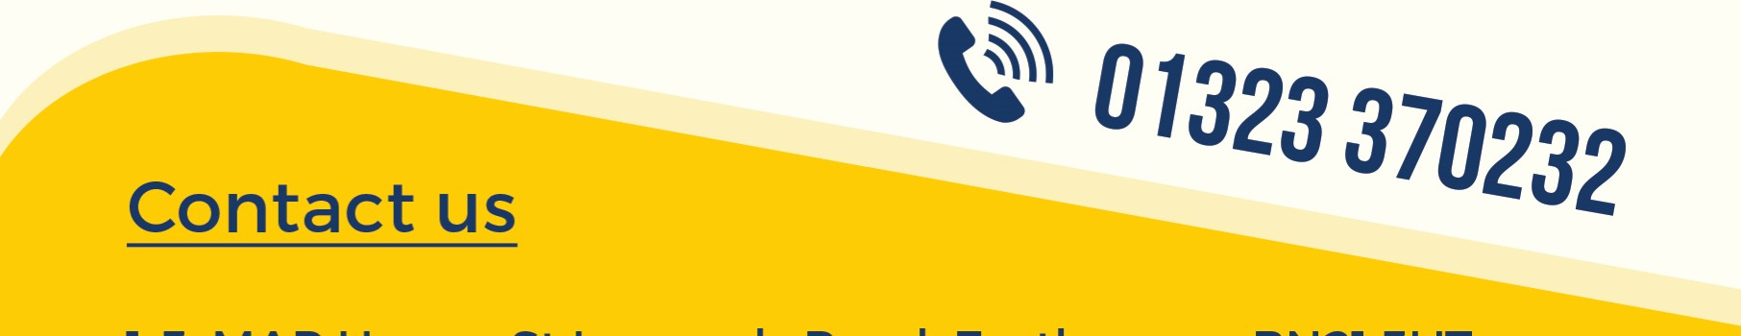
We've got you covered.
At Care 24/7 Healthcare, we provide trained professionals, qualified nurses, healthcare assistants and support workers in and around East Sussex and cater for both planned and emergency staffing needs.
Visit our website or call us today to see how we can help you.
1-3, MAP House, St Leonards Road, Eastbourne, BN21 3UT info@care247healthcare.co.uk - www.care247healthcare.co.uk

