

Care 24/7 Healthcare
Compassionate Home Care Services

Care 24/7 Healthcare
Care 24/7 Healthcare provides expert personal care services to an
extensive selection of domiciliary care users across the country, be
it private or referred through Social Services. We offer economical
healthcare services, accessible to service users from every background.
Care 24/7 Healthcare is dedicated to providing skilled staff, including,
but not limited to, carers, support workers and household assistants. We
emphasize matters of cultural sensitivity and acknowledge all outlooks
and lifestyle practices of various ethnic groups.
We provide our services to the elderly, as well as to other adults. We
customise services for each service user in our care, whether they require
more complex care services, such as spinal injuries, brain injuries, learning
disabilities or even just some company.

Our Care at Home Team
Our Care at Home team is equipped with a vast array of information and skills. Whether you need some advice, organisation, or interactive Care at Home package options, our staff will ensure that all your needs are met. Starting with your initial enquiry, right through to the delivery of your care, you will receive support every step of the way.
If necessary, we will provide carers who meet the service user’s language requirements, as well as ensuring the worker is a suitable match for the service user. We guarantee that the access to all services are appropriate and well-timed to the person’s needs.
Care 24/7 Healthcare will guide and empower those from different cultural backgrounds to make use of the health services with the knowledge that you will be treated with the utmost respect.

We acknowledge your choice to stay independent, and we hope to enable your loved ones to be more involved with your care – all without compromising on the quality of the care.

What is included

Personalised healthcare services
Our Care at Home facility provides social care by skilled healthcare professionals and support workers, ensuring prime service, personalised to each service user, accommodating cultural beliefs and values.

In-depth information from one of our advisors
Thanks to our experience in the sector, we can always provide service users with up-to-date information about our services, as well as geographical coverage and applicable costs. All our staff are mindful of cultural values and are capable of managing service users from all communities with the respect they deserve.

Free, no-obligation care assessment
We will send a staff member to visit you and perform a full evaluation of your needs and requirements. This will allow us to get to know you and understand any preferences you may have, as well as what care you will need. In addition, we can also liaise with any involved care professionals and your family.

Local expertise and knowledge
Since we have a committed team of carers across the country, we offer a national service while also providing local expertise. Care 24/7 Healthcare operates 24 hours a day, 7 days a week, so no matter the time of day, you know someone from our team will pick up the phone and address your concerns.

Considerations for your home
Sharing your home with someone can be a personal matter. So, we ensure that all of our live-in carers are fully aware of your expectations, religious beliefs, and cultural sensitivities.

Variety of care options
We realise that your requirements could change, which is why we ensure flexible care options, which you can choose based on your situation.

24-hour care
Our carers can visit your home on a rota basis during the day and night, covering the whole 24-hour period, ensuring that your needs are attended to 24 hours per day.

Daily visits
We can provide support with all the aspects of live-in care, with anywhere from one hour through to a full day (minimum visit length is dependent on your location. For more information please contact us directly).

Night care
Sleeping Night – This service is intended for service users who may only require a limited amount of care throughout the night, ensuring you have peace of mind that someone is there.
Waking Night – Alternatively if your requirements are more complex, our waking night service might suit your needs better. During a waking night, our staff member would stay awake and alert throughout the night to meet your care needs.
Which home care service is right for you?
All of our services can be combined to ensure you receive the full package when it comes to your healthcare needs.

Personal care
Designed for service users who require support with daily activities, our personal care service is personalised to your individual needs, including support with morning and evening routines, bathing, dressing, continence care, medication prompts and meal preparation. Staying mindful of cultural values, we will work closely with you to tackle any concerns that appear.

Social companionship
Our social companionship service is best suited to service users who are assured by having someone there with them. Maybe you need a helping hand with household chores or just someone to sit and chat with you, Care 24/7 Healthcare will be there for you.

Live-in care
For service users who need someone to assist them during both the day and night, our live-in care service* will be befitting to them. This service maintains a level of independence within the comfort of their own homes. One of our skilled staff members will live with you in your home and deliver one-to-one personalised care services.
*This service is based on a night of up to 3 disruptions.

Complex care
Service users with complex and continuous care requirements often need the support of highly trained healthcare professionals so they can continue living in their own homes. We can allocate practiced healthcare assistants with niche skills, tailored to meet your individual requirements.

Hospital to Home
Its not always a simple transition from a hospital stay to your own home. We can ensure you are settled back into your house smoothly with our hospital-to-home service. Working with both Discharge Teams and Occupational Therapists, we guarantee that service users receive optimum recovery whether they require some assistance with day-to-day activities or a complex level of care. Care 24/7 Healthcare will be there from the moment you are discharged from hospital.

Night care
A good night’s sleep is vital to our general wellbeing but for some, an unsettled night can be the cause of more complex care requirements throughout the day. Our two levels of night care services: Waking Night and Sleeping Night, we can ensure that the night time hours for you or your loved one pass with ease.
With our healthcare assistants by your side during the night, we can ensure that you are comfortable. With Care 24/7 Healthcare you can be rest assured that you won’t be on your own during your most vulnerable hours.

Palliative care
Palliative care is an intensive area of healthcare for service users with life-threatening illnesses. Care 24/7 Healthcare offers palliative care services catering for all possible stages of illness, including pre-diagnosis, diagnosis, treatment, cure, death and bereavement. We aim to provide the best quality of life for those suffering from a progressive illness, as well as their loved ones.


Minimum Visit Time
Throughout our years of experience providing care at home, we have realised that it is best not to rush a visit in order to ensure that you receive the best quality of care. This is why we offer minimum visit times between 1 to 4 hours depending on your location.
There should be no pressure to rush the tasks of daily living and we feel this is essential for the elderly or individuals with physical disabilities. Upholding safety in their environment is paramount.
We don’t want to rush our carers and we don’t want our carers to rush you. During visits, our staff can offer not only personal care but also company and conversation. Care 24/7 Healthcare is passionate about building strong, trusting relationships and we believe that investing time rather than dispersing little bursts of care that we will be able to do so.
We do offer a flexible service with customisable visit lengths, which can be modified to suit your requirements, in the event that you are seeking the comfort of someone visiting your home to check if you have everything you need. This could mean a carer visiting 2 to 3 times per week instead of daily visits or using their time to help you with other responsibilities such as domestic chores or community trips. This ensures you get the most out of your time with your carer and allows flexibility to create the best care plan that works for you.
To find out the minimum visit duration in your area, please call our dedicated Care at Home Team on: Tel.No. 01323 370232

Care 24/7 Healthcare and personalisation
In 2007 the Government published the Personalisation Agenda: ‘Putting People First’, in response to transforming adult social care in England over the next 10 years.
Personalisation aims to revolutionize the way that people think about care and support services. This change in reform calls for a substantial change in adult social care so that all systems, processes, staff and services are focused on putting people first.
Personalisation is about offering more choices and control over your life in all care situations and is far broader than simply handing out personal budgets to people eligible for government funding. It involves advice and encouragement to enable you to make informed decisions about your care.

We are always willing to meet and discuss any challenges you face and identify a potential solution to ensure our services are delivered in accordance with the Personalisation Agenda.
If you would like to find out more about ‘Putting People First’, visit the TASC (Transforming Adult Social Care) website at www.tasc.org.uk.
We always strive to place you at the core of our services and consult with you every step of the way in the delivery of your care. Our care at home services, whether provided directly by the council, paid for independently, or by personal budget holders, endeavours to focus on identifying and achieving outcomes.
The type of support that people who use our services say they need are not limited to personal care. It can consist of a much broader range and it is likely that such services as domestic help, assistance with household management, being taken out for the day or even help to enable a holiday to be taken, will be necessary.
As an establishment, we are as adaptable as are our staff and are always finding solutions rather than dwelling on what can sometimes be considered impossible problems.
How is our service delivered?
The steps below highlight the fundamental phases that Care 24/7 Healthcare follows to deliver a tailored care service.
- We receive your enquiry, examine your requirements, and specify an overview on the services we can offer, as well as a summary of prices.
- A Care 24/7 Healthcare assessor visits your home and a care and risk assessment is taken. After this visit, a care plan will be presented.
- We finalise your care plan with you and your family, if necessary.
- We find fitting staff members to support you according to your care requirements and organise a meeting. If any additional preparation is required, this will also be organised.
- Your care service begins.
We realise that in an emergency situation a care package must start immediately. In this event, we will condense our service process and begin an immediate assessment to assist with an earlier response.

Funding your care
Although this isn’t always the case, most people think that services such as personal care would be expensive. There are various finance options that ensure you or your loved one remain in the comfort of your home.
Should you need any help with financing your care, you might qualify for funding from your Local Authority or the NHS Continuing Healthcare Team. Below is a brief explanation of the types of support available.

1. Personal budgets
A Personal Budget is a lump sum set aside to cover your healthcare requirements. You can either accept the amount personally as a Direct Payment or you can request your local authority to use this money on your behalf. It can also be allotted to a trust fund managed by your family or by a professional such as a social worker.

2. Individual budgets
An Individual Budget is similar to a Personal Budget, although, it can be a more flexible budget option and involves other sources of support such as Supporting People, Disabled Facilities Grant, Independent Living Funds, Access to Work and Community Equipment Services.

3. Direct budgets
A Direct Payment is money given to you directly so that you can buy services for your care needs, which puts you in complete control of your care package and provider.

4. Personal Health budgets
A Personal Health Budget is an allowance made to a person with a recognized health concern. At the moment the NHS offer Personal Health Budgets in 3 options: Notional Budget, Real Budget Held by Third Party, and Direct Payment. Find out more about this by visiting the Department of Health website: www. dh.gov.uk.

Quality assurance and our recruitment standards
Care 24/7 Healthcare’s character is dependent on offering an exceptional standard of care. We follow a strict employment process to ensure we only supply care staff who are compliant. We are proud of the rigorous internal Quality Assurance Systems that are continually reviewed and monitored.


We require our care staff to have relevant qualifications and experience for the services they will be asked to provide. In some cases, candidates will already have achieved qualifications such as NVQ Level 2 or 3.
Our team checks each candidate’s Disclosure Barring Service (DBS), POCA and SOVA checks, work history, health declaration, experience, qualifications and up-to-date references to ensure we have a complete description of their capabilities. We also assess their ongoing training needs, ensuring that staff continue to provide an excellent level of service.
Care 24/7 Healthcare’s recruitment process complies with:
- The Care Standards Act 2014
- The Regulation of Care Act 2014
- DoH Code of Practice of NHS Employers
- All current NHS National Framework Guidelines
Care 24/7 Healthcare obeys a rigorous employment process to certify that all our staff are compliant with the Care Quality Commission (CQC). This allows us to supply our service users with the highest quality healthcare professionals, at all times.
Fixed observations guarantee that our staff uphold the standard of care. We oversee compliance evaluations to guarantee that all our staff have the appropriate credentials and proficiency needed for the care that they will deliver.
This includes:
- Disclosure and Barring Service (DBS) checks.

- A full health statement.
- Full working experience, including detailed reference checks.
- Annual reviews with applicable registration bodies to guarantee ability to practice.
- Regular supervisions ensure that our staff continue to provide an excellent standard of care.

Training
An emphasis on constant training and development is essential to Care 24/7 Healthcare’s reputation. Our staff members are proficient in the National Standards and all take part in a comprehensive compulsory training course which includes manual handling, disease control, basic life support, fire safety and medication sections. In addition, as part of our Care at Home service, we build personalized instruction briefs based on the needs of each service user.
Q: Is Care 24/7 Healthcare registered with the appropriate governing bodies and professional associations?
A: Yes, we are registered with the Care Quality Commission (CQC). This guarantees that we supply our service users with the highest quality of care and staff. All of our certifications cover our domestic services countrywide.
Q: Will someone visit my home before starting the service?
A: Yes, a complete Care Assessment will be conducted to ensure that the package of care we provide is fully tailored to the needs of the service user. The evaluation will take roughly 1 hour and contains an overview of requirements and a general risk assessment for the setting where the care will be delivered.
The conclusions of the evaluation will form the foundation of the care plan and will feature comprehensive evidence which the carer will follow when supplying your care. Care 24/7 Healthcare has a lawful accountability to guarantee that a care plan is in every household in which our services are being offered and to confirm that they are frequently assessed.
As well as permitting us to formally record all of our service users’ needs, the evaluation also allows us a clearer understanding of any individual needs, consequently, allowing us to designate staff with skills that suit the service user’s character and preferences.
Q: Will I always receive care from the same carer?
Frequently
asked questions
A: We strive to see to it that you continuously receive care from the same carers. Once we commence your care, we will present more than one carer to you and your family to guarantee that there is a level of consistency, in the event of any holidays or absences.
Q: How will my care be managed?
A: All of our specialised care packages are managed by our Registered Manager who ensures that each service user’s care is regularly reviewed and managed effectively. We are also available to contact should you have any particular concerns.
Q: What makes Care 24/7 Healthcare stand out?
A: Care 24/7 Healthcare is run by experienced individuals, and this gives us have an intuitive view into what our service users need. While our established contacts mean we can guarantee flexible, dependable and experienced assistants.
Care 24/7 Healthcare is aware of the need for expertise in this sector, that is why we only employ staff with certified references and after undergoing thorough checks. This gives our service users the confidence to use our services, because they know that the staff have been properly selected, and additionally adequately trained and capable of performing their appointed positions.
We believe that our high standards of expertise and quality of service mean nothing without value for money. Care 24/7 Healthcare bargains an appealing package that is reasonable to employees.

What we believe in
We strive to provide an environment that enables individuals to reach their highest potential and work towards overcoming emotional and behavioural complications.
To do so, we believe in:
- The Civil and Human Rights of those in our care.
- Working together with service users to develop unconventional solutions to conflicts to complications.
- Applying non-prejudicial methods and celebrating individual differences.
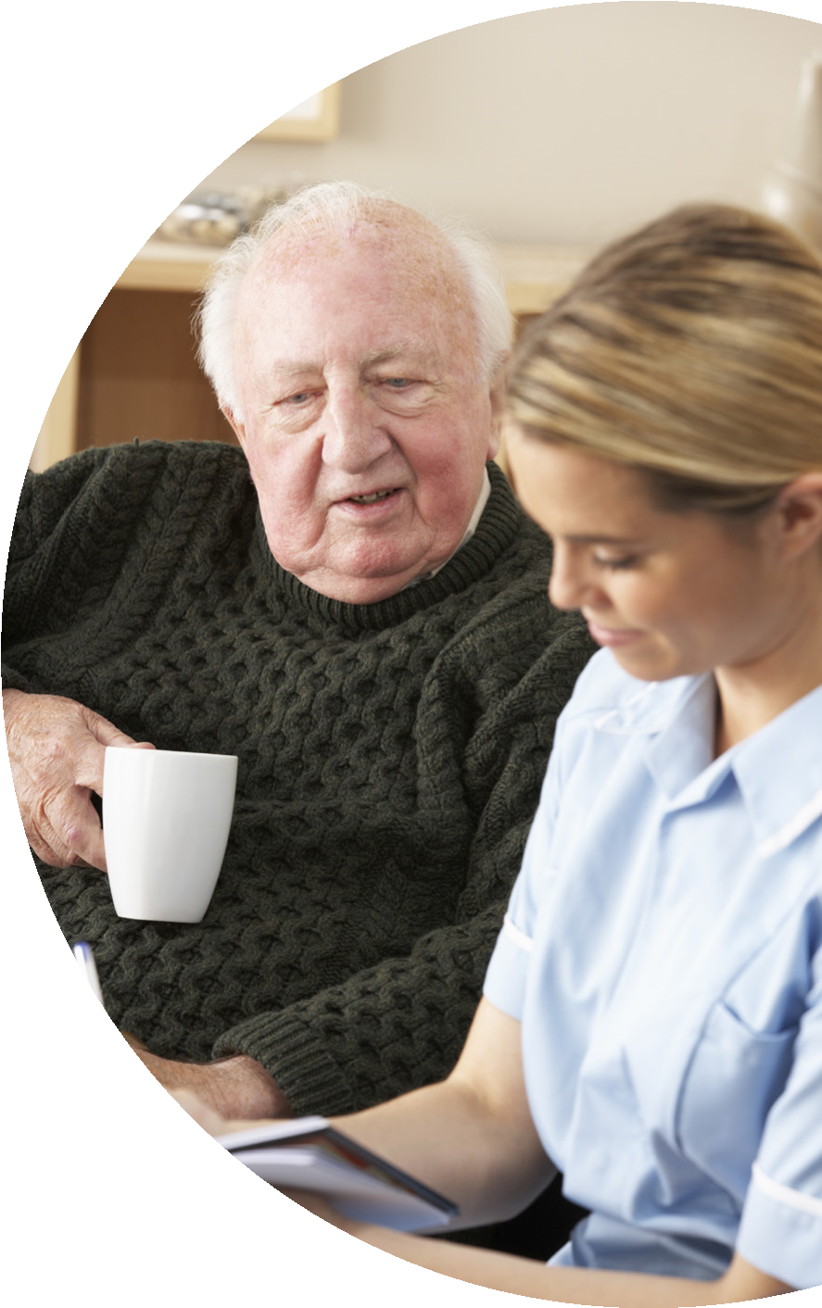
- Providing detailed Care Plans for service users and examining these once a year, or as necessary.
- The provision of appropriate support and stimulation via carefully monitored, reasonable risk taking, to enable independence.
- Providing a 24-hour service to service users, families, and Social Services.
- Ensuring the highest possible standard of staff recruitment and selection.
- Encouraged training and development that enables employees to further develop their professional and care skills.
- Providing an atmosphere of mutual respect between service users and staff to uphold the dignity of the individual.

What should you do now?
If you have any queries about the services we provide, please do not hesitate to get in touch.
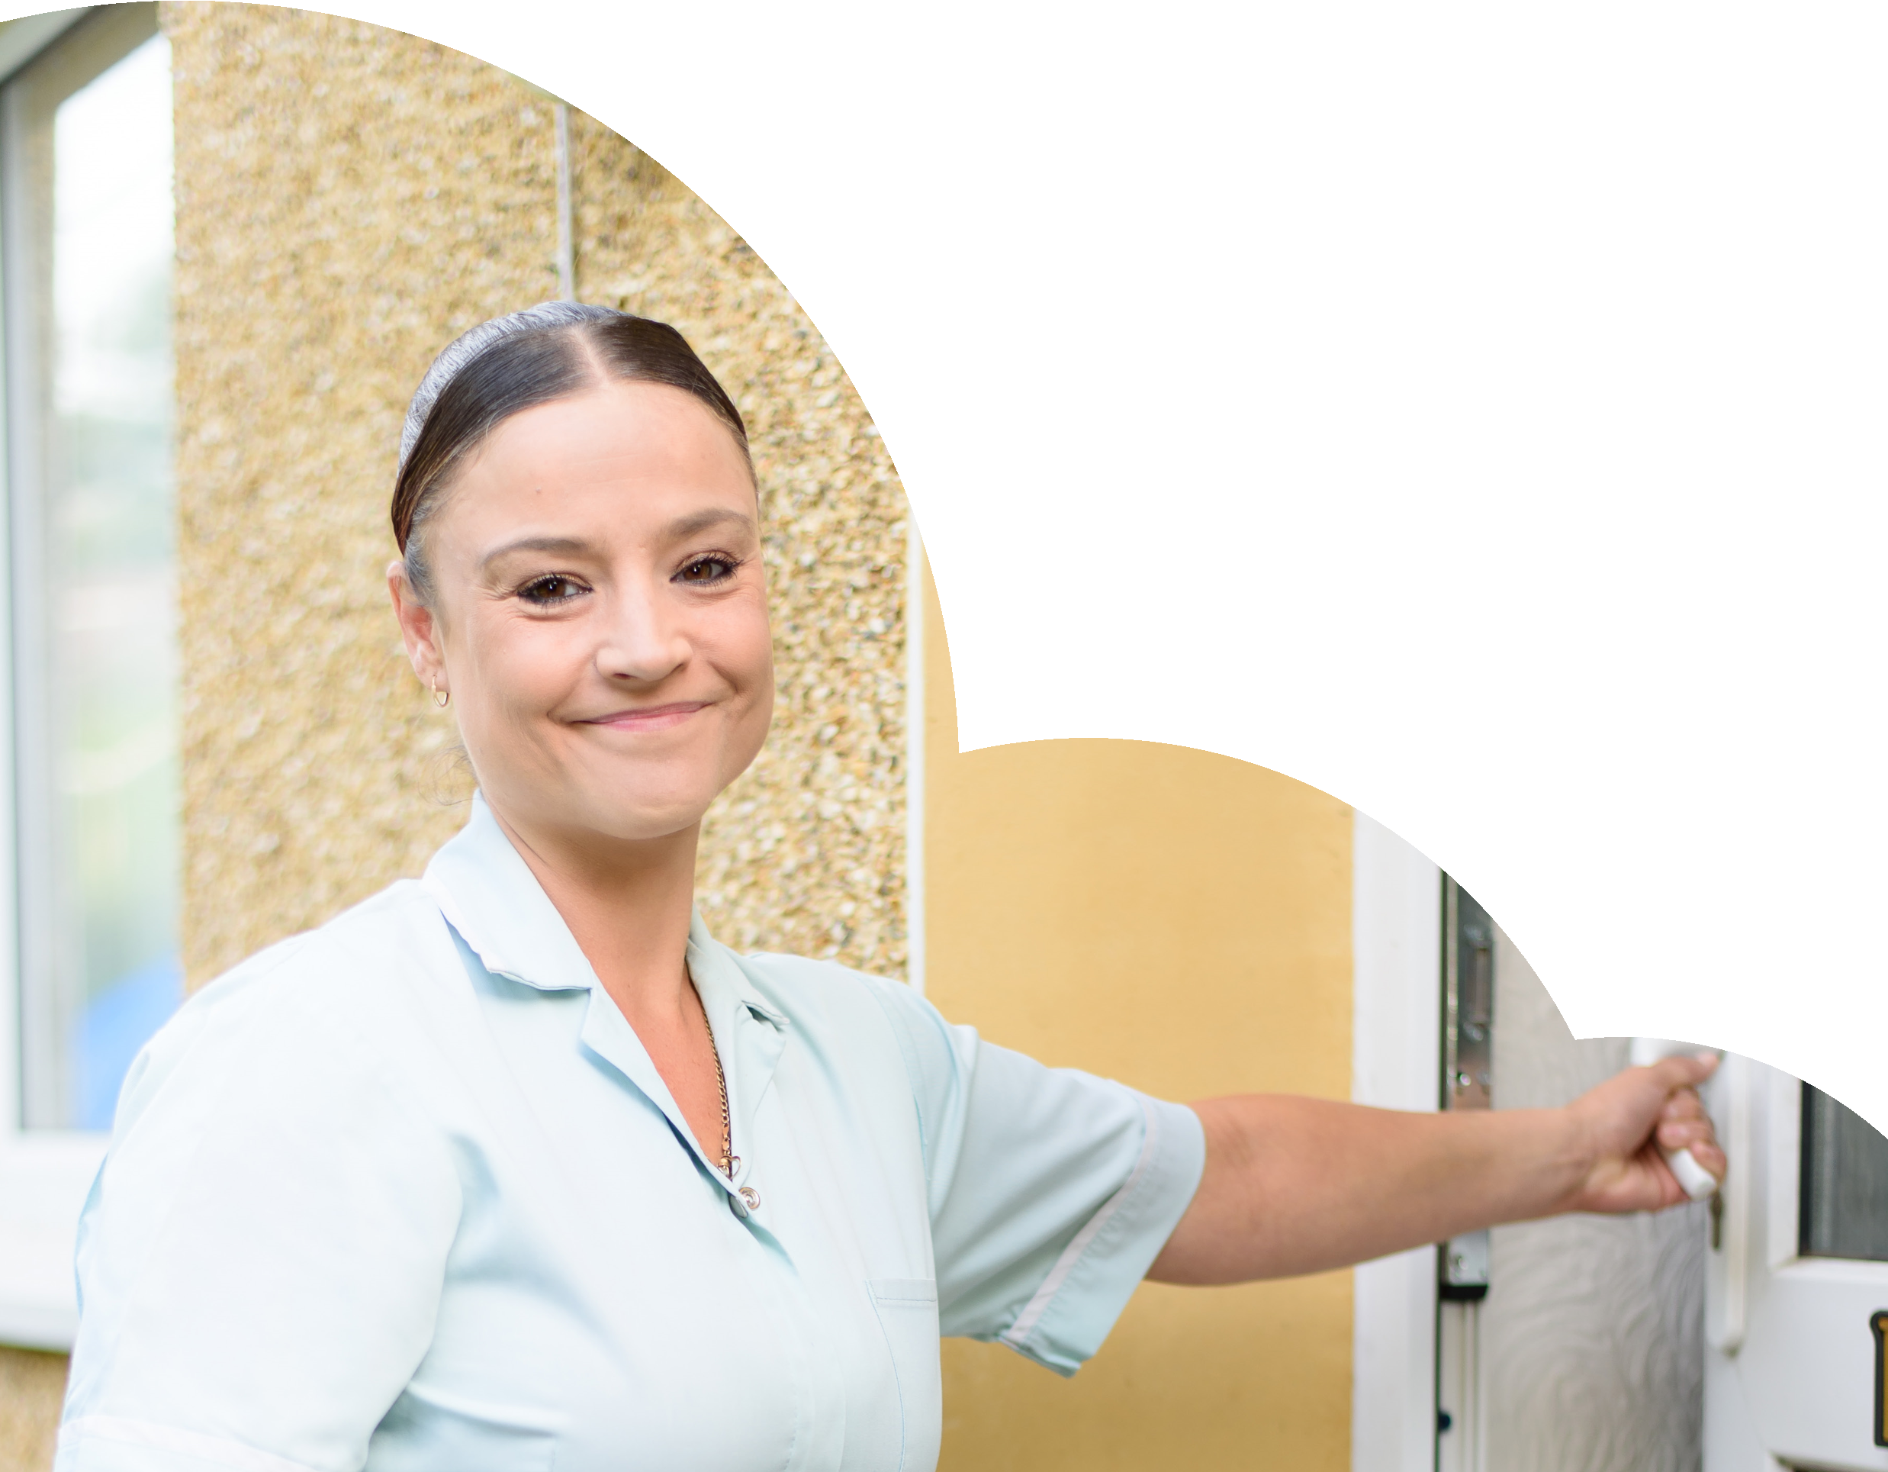
Contact:

Care 24/7 Healthcare Limited
Address: 1-3, MAP House, St Leonards
Road, Eastbourne, BN21 3UT
Registration Number: 09909827
T: 01323 370232 E: info@care247healthcare.co.uk
W: www.care247healthcare.co.uk

