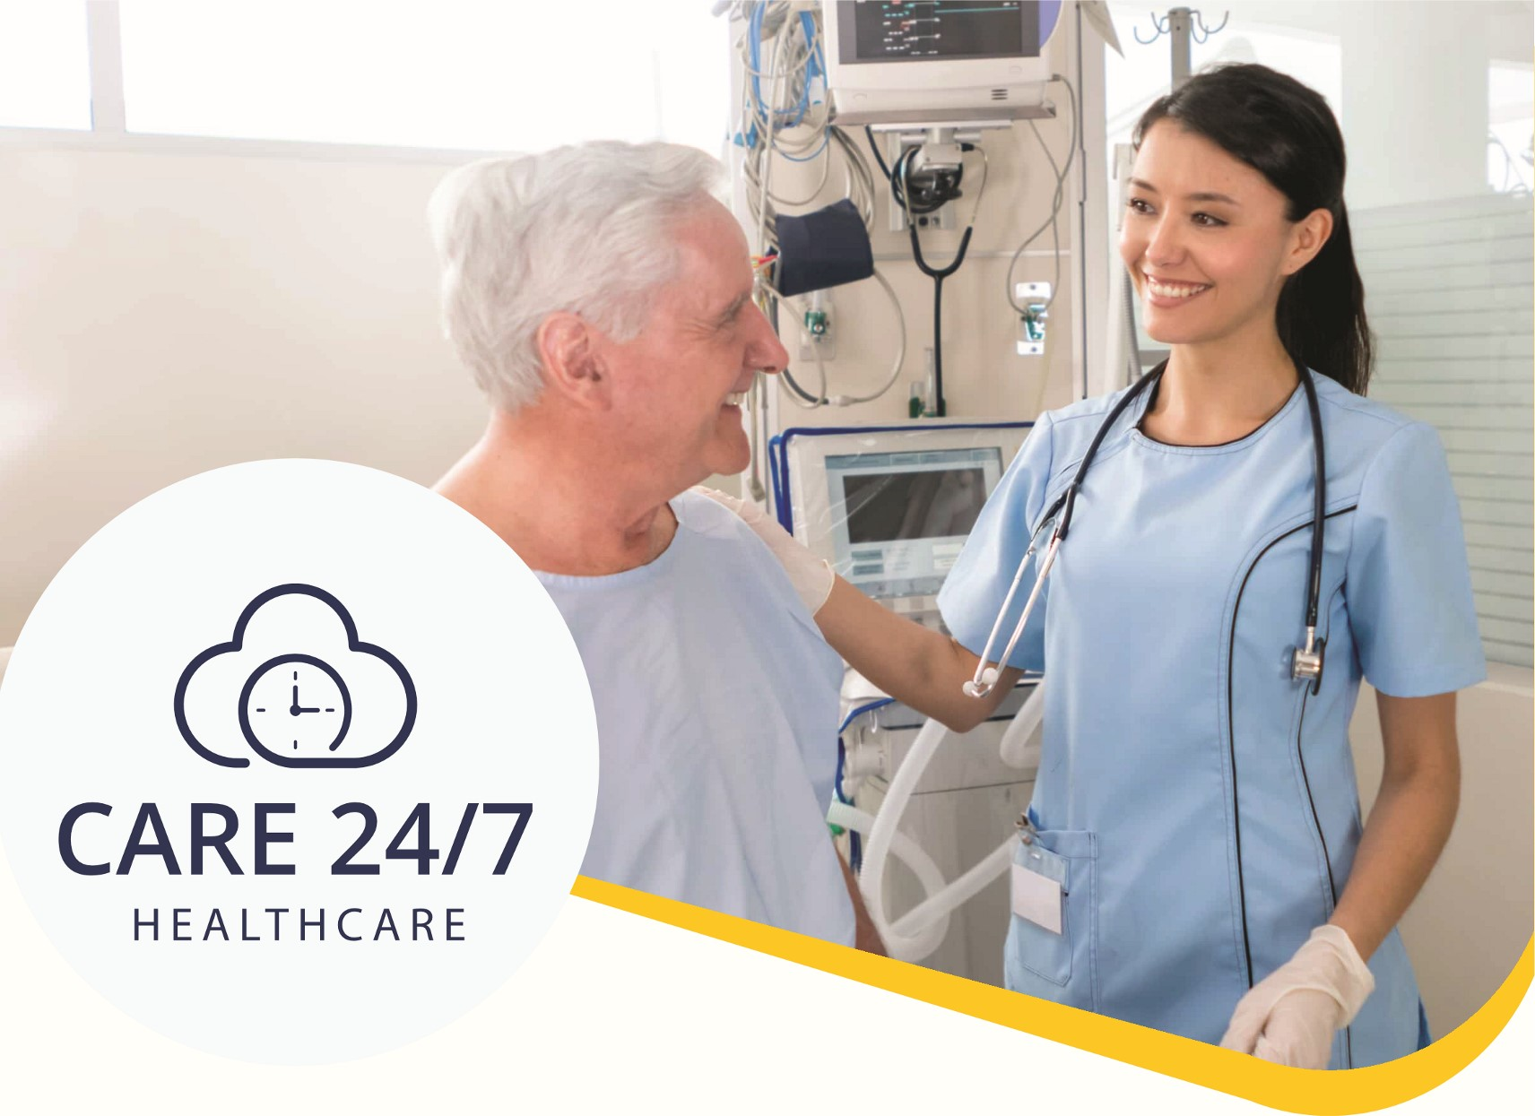
Are You Looking For
e Flexible Shifts, e Great Staff Pay, e Immediate Start?
We are recruiting: Nurses (RGNs, RMNs, RNLDs and other specialities),
Carers, Support Workers, Healthcare Assistants and many more!

01323 370232
Contact
1-3, MAP House, St Leonards Road,
Eastbourne, BN21 31JT info@care247healthcare.co.uk www.care247healthcare.co.uk

